Cognos Training

Exercises

Revision History

|  |  |  |  |
| --- | --- | --- | --- |
| **Version Number** | **Date Updated** | **Revision Author** | **Brief Description of Changes** |
|  |  |  |  |
|  |  |  |  |
|  |  |  |  |
|  |  |  |  |
|  |  |  |  |
|  |  |  |  |

Table of Contents

[1. Exercises: 4](#_Toc456271128)

[1.1. Web Based Interfaces 4](#_Toc456271129)

[1.1.1. User Interface and Navigation 4](#_Toc456271130)

[1.1.2. View Objects 4](#_Toc456271131)

[1.1.3. Run an existing report from Cognos Connection. 5](#_Toc456271132)

[1.1.4. Open Report Analytics 6](#_Toc456271133)

[1.2. Report Analytics 7](#_Toc456271134)

[1.2.1. Open an Existing report 7](#_Toc456271135)

[1.2.2. Creating a Report 8](#_Toc456271136)

[1.2.2.1 Templates and Reuse a Layout object 8](#_Toc456271137)

[1.2.2.2 Types of Reports 9](#_Toc456271138)

[1.2.2.1 Creating New Report 10](#_Toc456271139)

[1.2.3.1 Add Data to a Report and Save It 13](#_Toc456271140)

[1.2.4.1 Create a Grouped List Report 17](#_Toc456271141)

[1.2.5.1 Create a New Cross-tab Report 20](#_Toc456271142)

[1.2.6.1 Create a Column Chart 22](#_Toc456271143)

[1.2.7.1 Visualizations 24](#_Toc456271144)

[1.2.8.1 Add a Prompt 27](#_Toc456271145)

[1.2.9.1 Build a Cascading Prompt 30](#_Toc456271146)

[1.2.10.1 Perform a Calculation on a Report 32](#_Toc456271147)

[1.2.11.1 Auto Group and Summarize Filter 35](#_Toc456271148)

[1.2.12.1 Filter on Details 37](#_Toc456271149)

[1.2.13.1 Create a Summary Filter 39](#_Toc456271150)

[1.2.14.1 Drill Through 39](#_Toc456271151)

[1.2.15.1 Master Detail Report 43](#_Toc456271152)

[1.2.16.1 Conditional Formatting 46](#_Toc456271153)

[1.2.17.1 Data sets 51](#_Toc456271154)

[1.2.18.1 Exercises 51](#_Toc456271155)

## 

## Exercises:

## Web Based Interfaces

### User Interface and Navigation

**Steps:**

1. Open the Internet Explorer(I.E 11) web browser.
2. To access the Cognos Connection web site, type the following URL in the browser’s Address field and then press ENTER:  
   [http://10.74.161.177:9300/bi/v1/disp](https://webmail.in.capgemini.com/owa/redir.aspx?SURL=YHW2ArmKRMcKqH-ZmJFjTTc7oN5-gZZxH0hnuxFAgjD9hol_QarTCGgAdAB0AHAAOgAvAC8AMQAwAC4ANwA0AC4AMQA2ADEALgAxADcANwA6ADkAMwAwADAALwBiAGkALwB2ADEALwBkAGkAcwBwAA..&URL=http%3a%2f%2f10.74.161.177%3a9300%2fbi%2fv1%2fdisp" \t "_blank)
3. On the next Log on screen, type <UserId> in the User ID box, and <password> in the Password box, and then click OK.
4. You should see a window similar to the following:

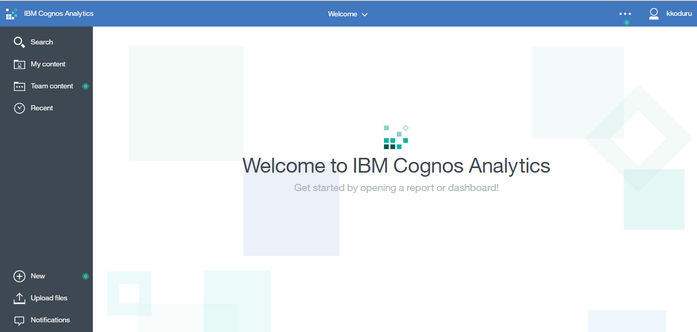

### View Objects

1. In the Cognos connection page, Click on the Team Content tab/link to view the reports/contents.

**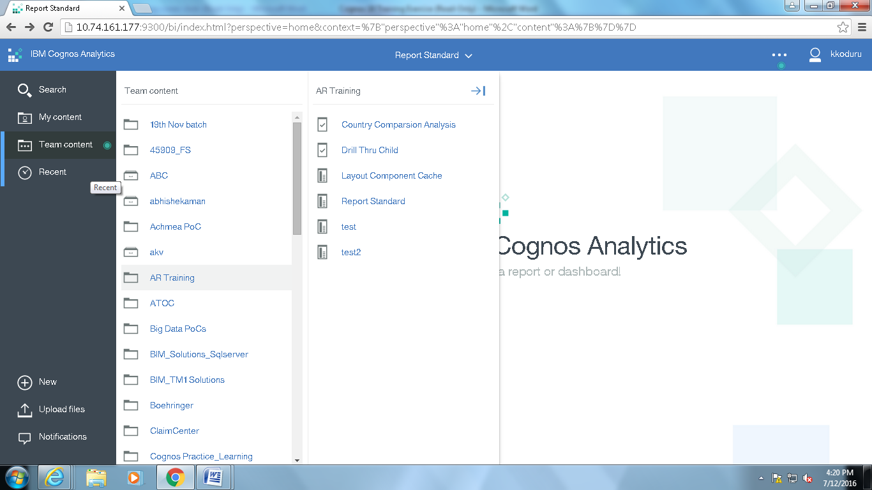**

1. In the Cognos connection page, Click on the My Content tab/link to view the reports/contents of My Contents

**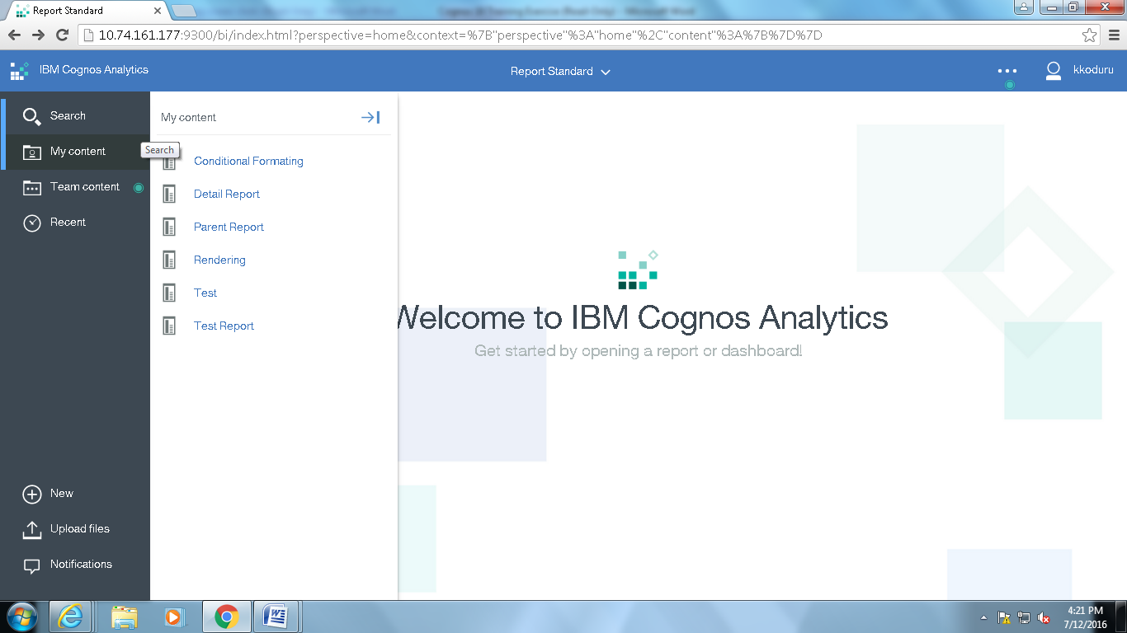**

### Run an existing report from Cognos Connection.

1. Login to Cognos Connection
2. Click on Team Content > [Samples](http://10.74.161.177/ibmcognos/cgi-bin/cognos.cgi?b_action=xts.run&m=portal/cc.xts&m_folder=i11DBEB7511FC45C882D2F8716F12CEC3&m_folder2=m-i5AA0A2E9017A4965B552C4C1523CF7A1) > [Models](http://10.74.161.177/ibmcognos/cgi-bin/cognos.cgi?b_action=xts.run&m=portal/cc.xts&m_folder=i923F87AC780343A7B964002DC08F1923&m_folder2=m-i5AA0A2E9017A4965B552C4C1523CF7A1)
3. Select a package ‘**Go Data Warehouse (analysis)’**
4. Click on the report name link to run a report.

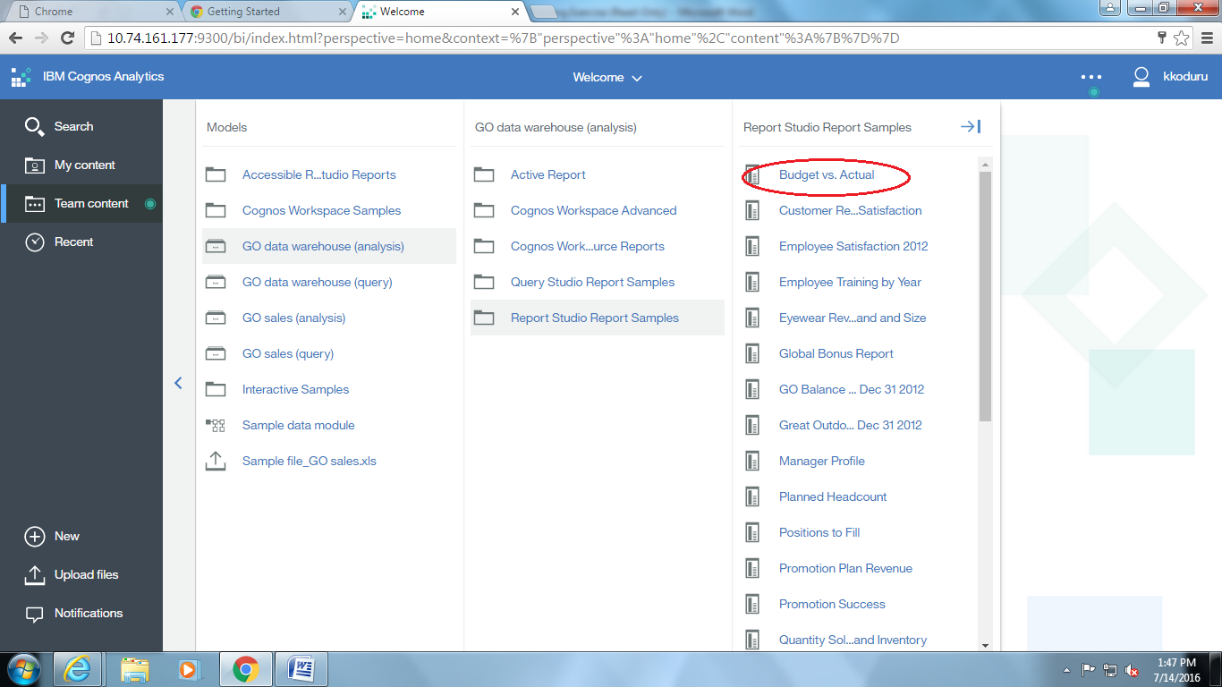

### Open Report Analytics

1. Login to Cognos Connection
2. Click on New, Click again on **Report**

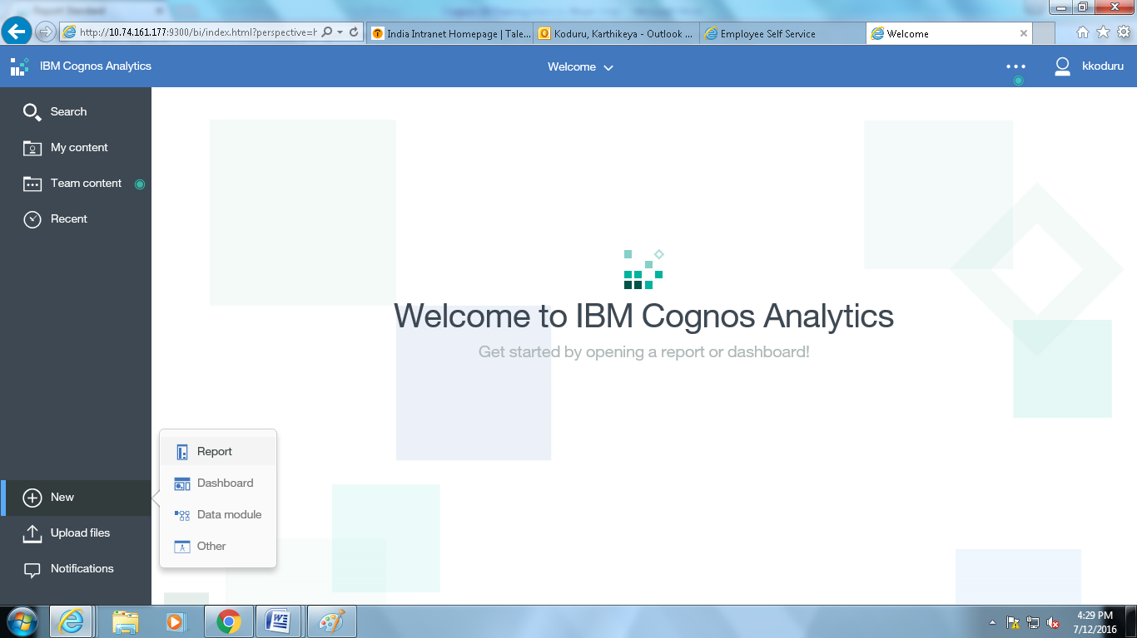

## Report Analytics

### Open an Existing report

1. Login to Cognos



1. Click on Team Content > [Samples](http://10.74.161.177/ibmcognos/cgi-bin/cognos.cgi?b_action=xts.run&m=portal/cc.xts&m_folder=i11DBEB7511FC45C882D2F8716F12CEC3&m_folder2=m-i5AA0A2E9017A4965B552C4C1523CF7A1) > [Models](http://10.74.161.177/ibmcognos/cgi-bin/cognos.cgi?b_action=xts.run&m=portal/cc.xts&m_folder=i923F87AC780343A7B964002DC08F1923&m_folder2=m-i5AA0A2E9017A4965B552C4C1523CF7A1)
2. Select a package
3. Select the package, **‘Go Data Warehouse (analysis)’**.
4. Select report you want to open, say **Budget vs. Actual** and Right Click and click On edit.

**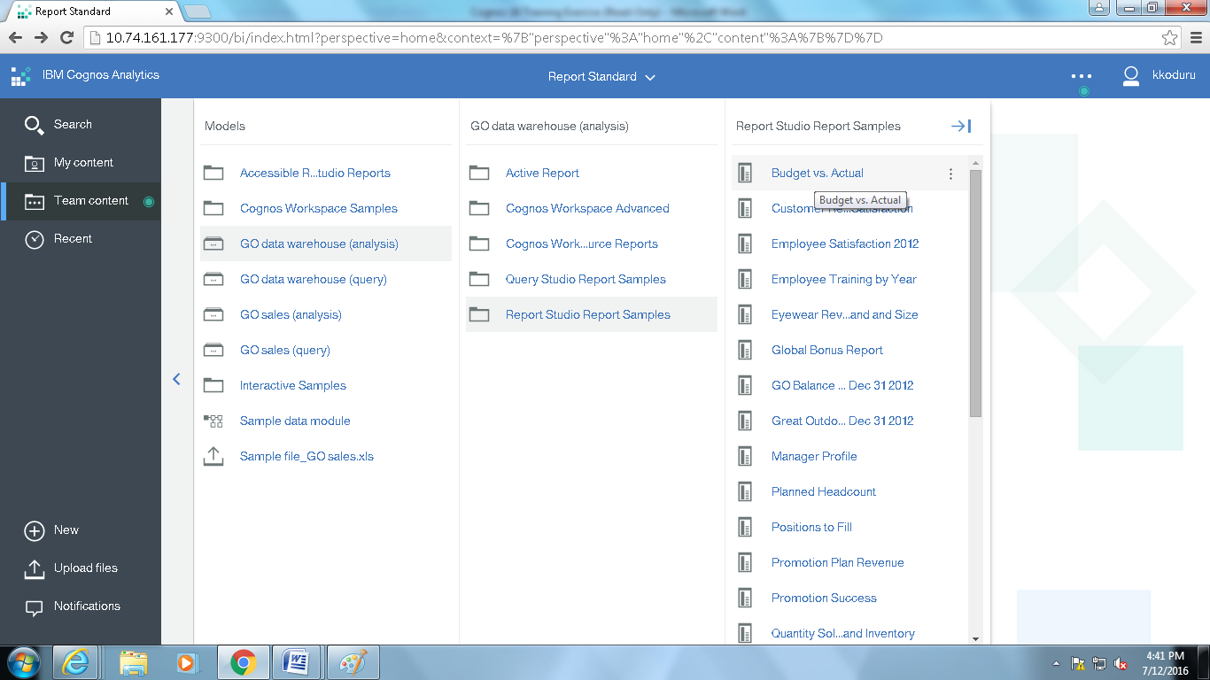**

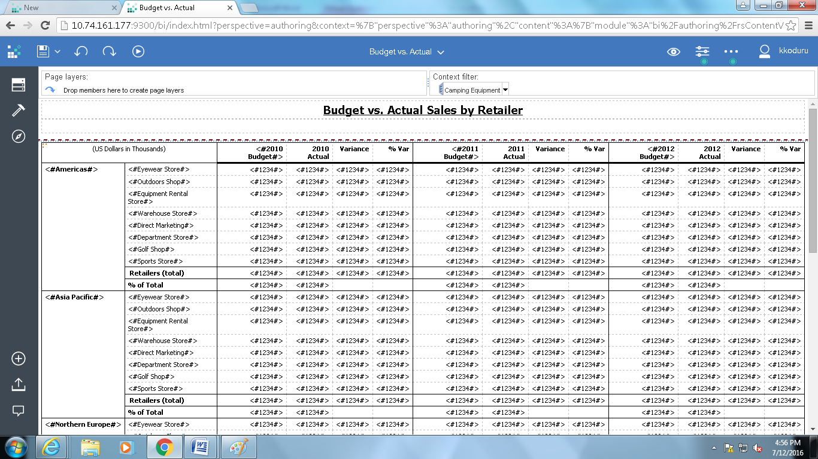

1. Report will be opened as shown in above screen shot.

### Creating a Report

### Templates and Reuse a Layout object

### 

* You can save time by reusing Layout Objects, which you add to a report, instead of re-creating them.
* For example:
  + You have a multiple-page report and you want to show the company logo in the page header of each page.
  + Insert the logo once and reuse it on all other pages.

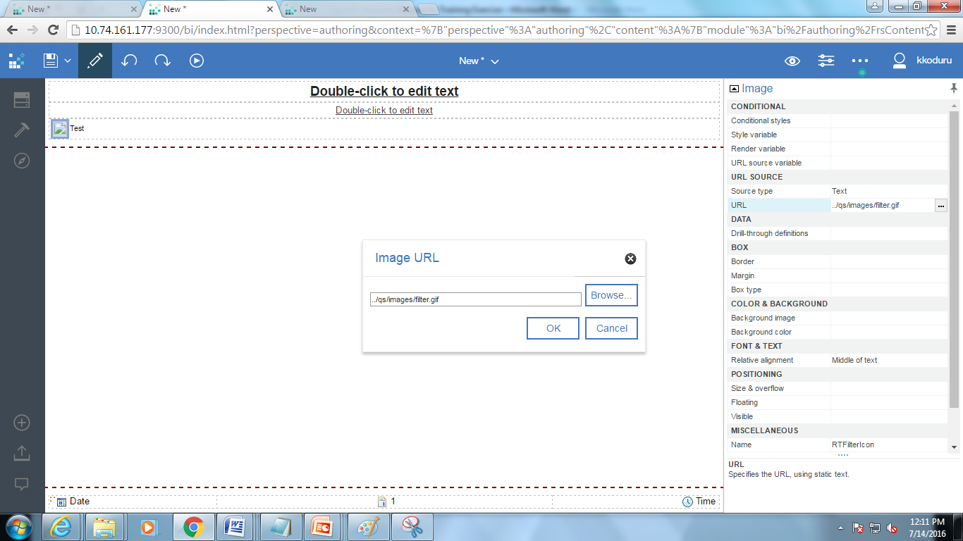

### Types of Reports

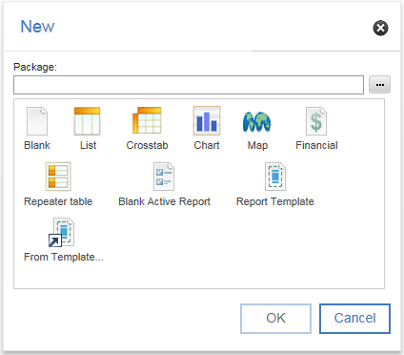

### Creating New Report

* + - 1. Report Types & Design Vs Preview Vs Structure

1. Login to Cognos Connection
2. Click on New, Click again on **Report**



Click List to select a list report and click OK. You will see a window like the one below:

### 

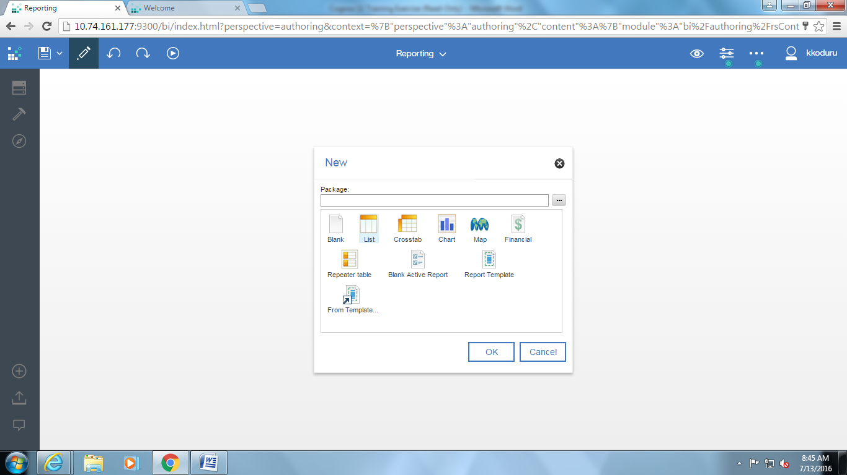

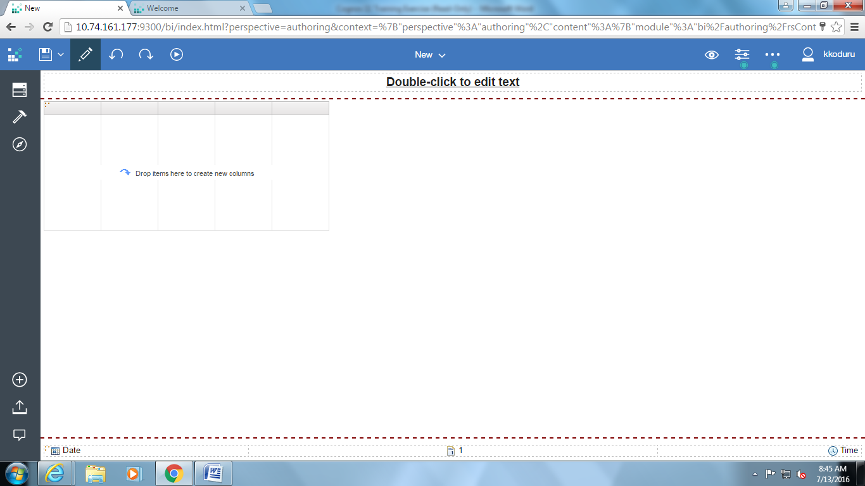

1. You should see the Select a package window, similar to the following, that contains the packages you can use:

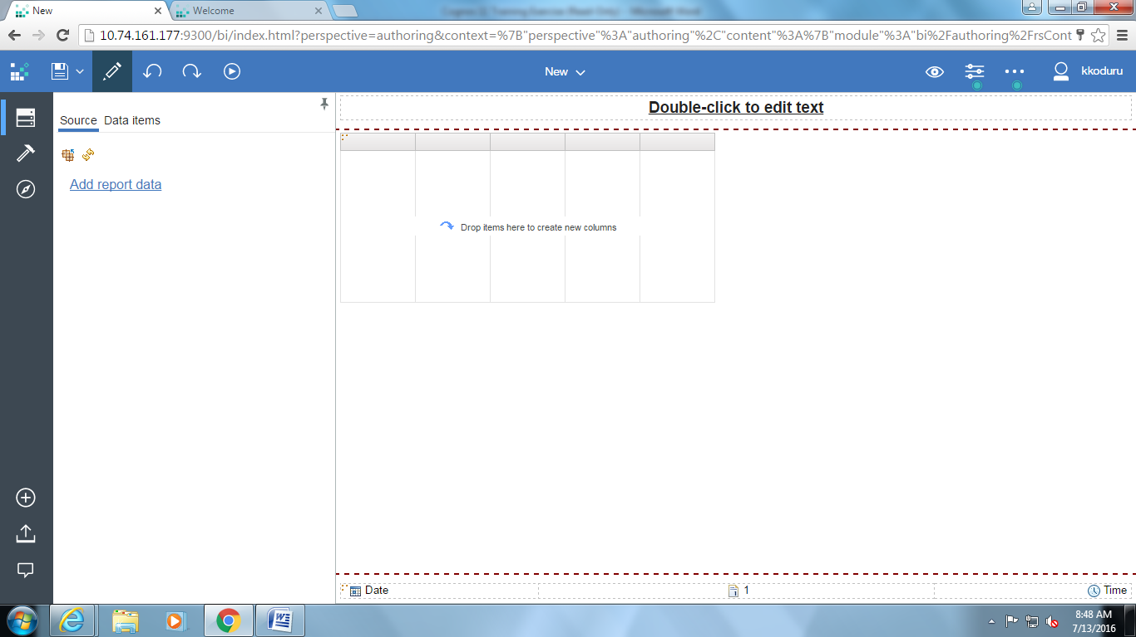

Click on  to select package.

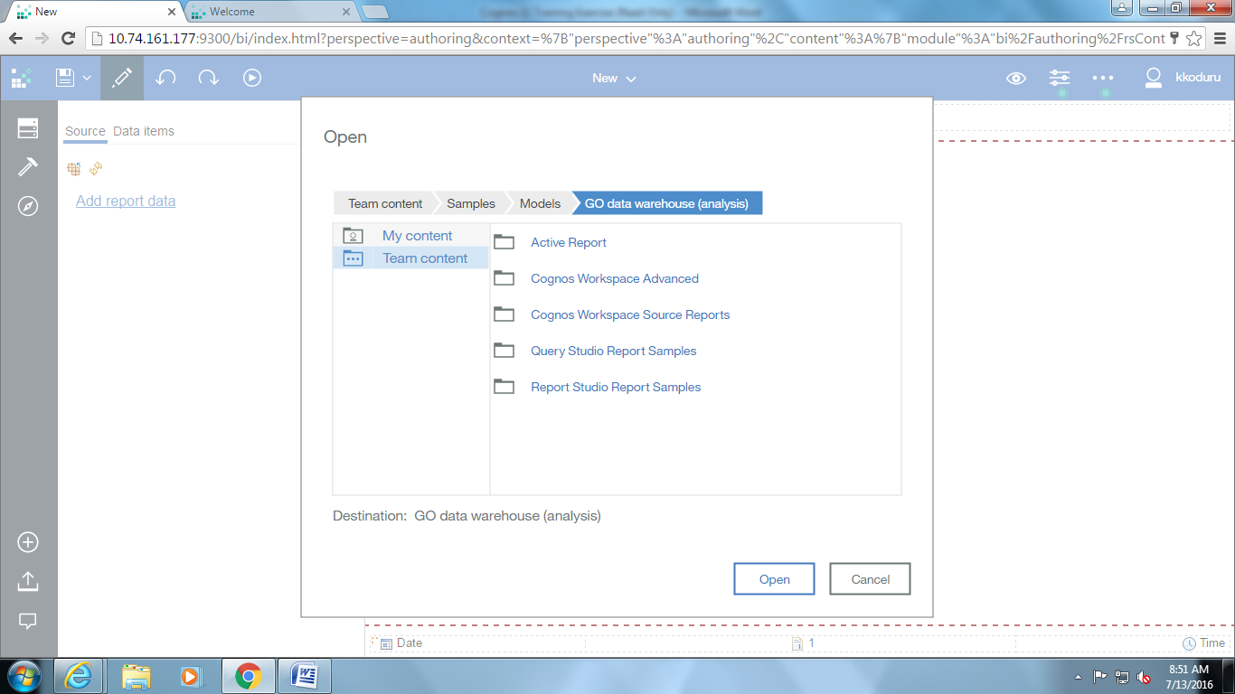

1. Click Go Data Warehouse (analysis).
2. Report will open and you will see a window similar to the following:  
     
   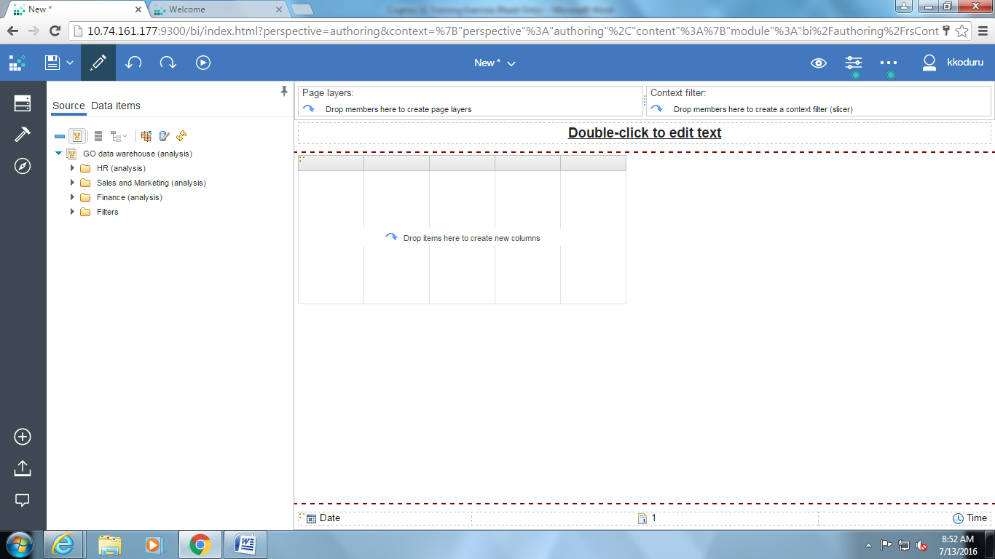

### Add Data to a Report and Save It

1. On the Source tab of your list report, click the plus sign to expand the **Sales and Marketing** item. Then click **Sales** item.
2. Expand **Retailer** item and Click **Retailer name**.
3. Hold down the CTRL key, expand the **Product** item and click **Product type**.
4. Continue to hold down the CTRL key and in the **Sales Fact** item, click Quantity and Revenue.
5. Drag the selected items to the work area and release the mouse button when you see the bold black bar.  
   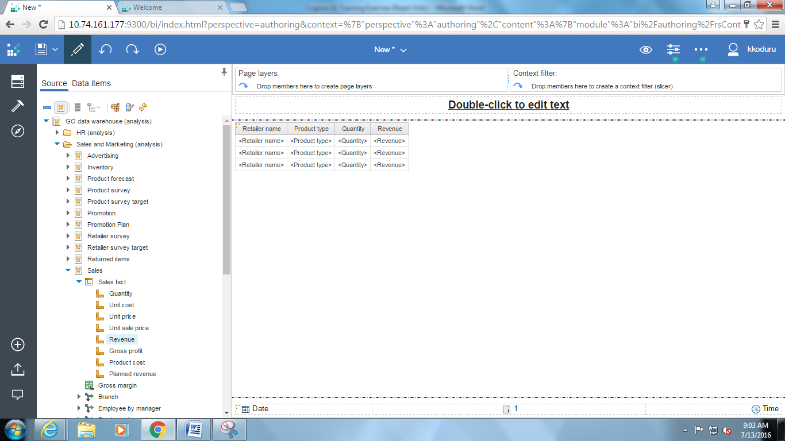  
     
     
   Notice that no data appears in the report yet. Run the report to see the data.   
     
   You can obtain information about your report’s structure and the items it contains by selecting some of the other tabs and features in the window:
6. Click the title of the **Retailer name** column.
7. On Demand Property’s pane  
     
   This produces a list of properties like the one below in the Properties pane at the Right side of the window:   
     
   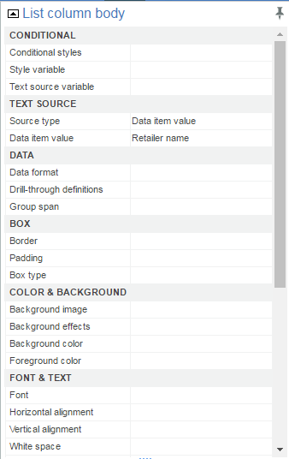  
     
   Note that this is a partial list; scroll down to see the remaining properties available to apply to the Retailer name column.
8. In the Insert able Objects pane, click the Query Items tab to see the structure of the query that Report has created from your items:

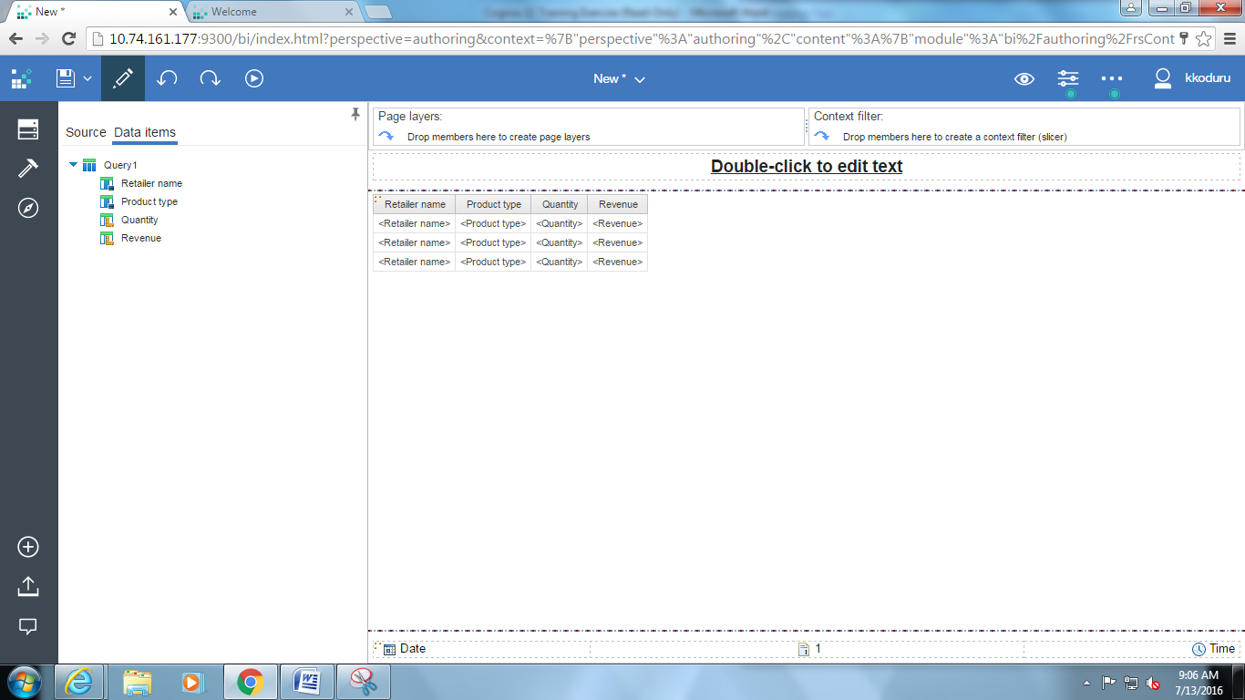

Next, you will save your report.

1. On the Menu, click Save As. You will see a box like the one below:

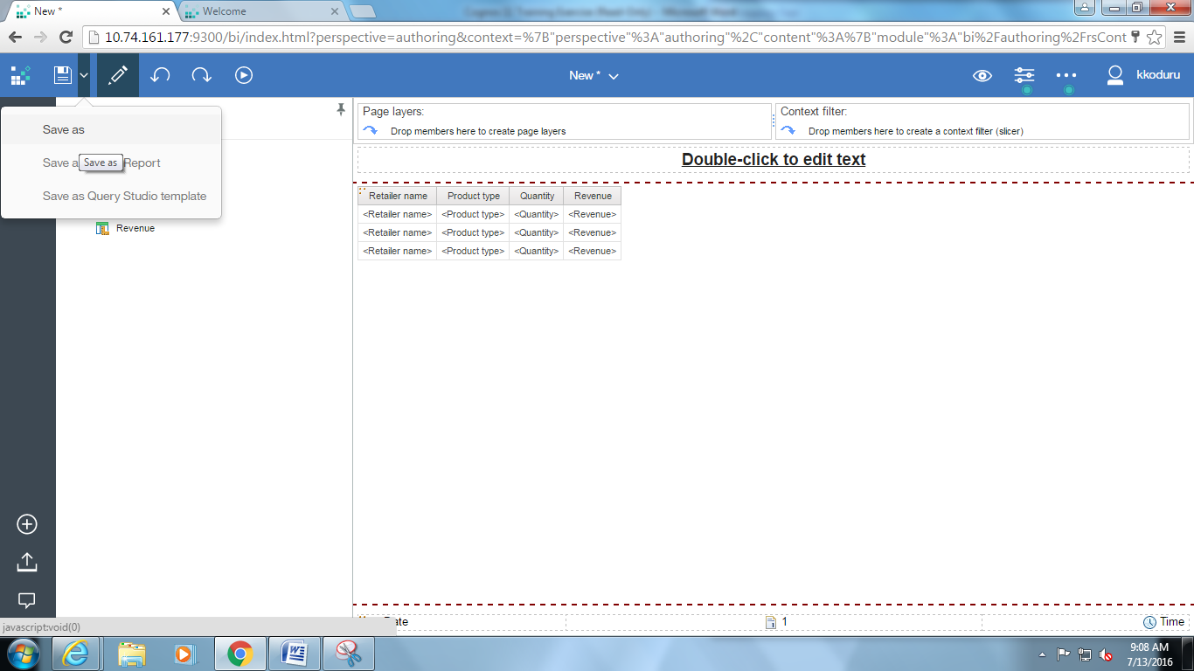

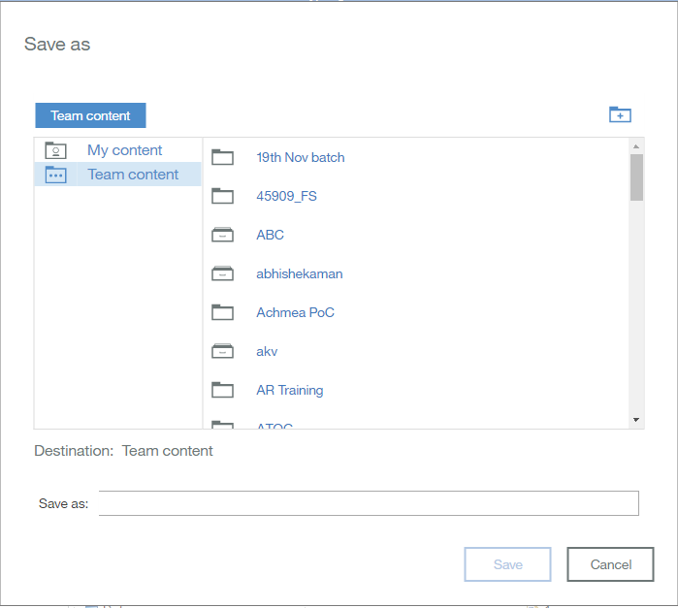

1. Select the location where you want to save the report.
2. In the Name box, type name of report and Click Save.
3. Click the Run  button’s and select Run Report (HTML).
   * + 1. Report Studio Views

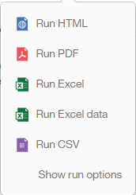

Your results will appear in a separate Report Viewer window like the one below. Note that the window below shows a partial list; scroll down to see the remaining data.  
  
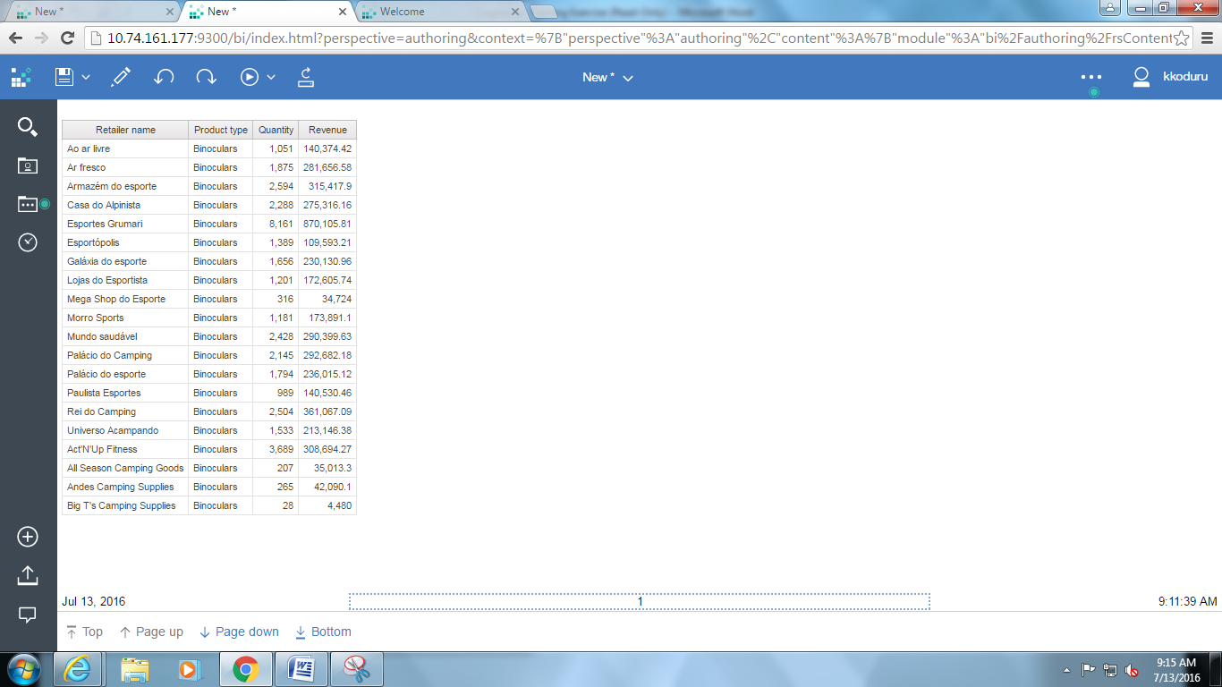

### Create a Grouped List Report

1. On the Cognos connection, click the New 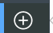 button to create a new report.
2. In the New box, select List and click OK.
3. On the Source tab, expand Sales and Marketing -> Sales items by clicking the plus sign.
4. Expand Branch -> Branch and click Country.
5. Hold down the CTRL key, expand the Products item; click Product type and Product.
6. Drag the selected items to the work area and release the mouse button when you see the bold black bar.  
     
   You will see a window like the one below:  
     
   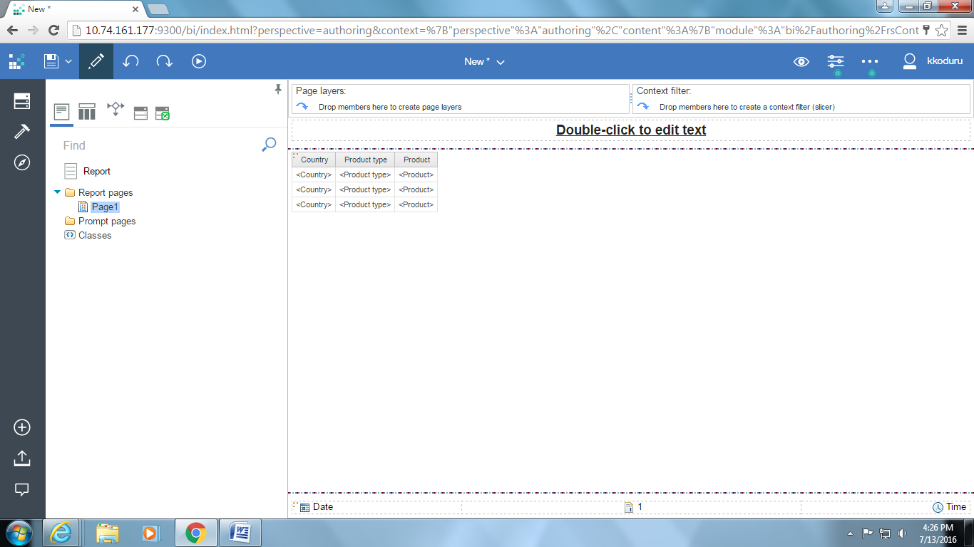
7. On the toolbar, click the Run  button’s down-arrow and select Run Report (HTML).  
     
   Notice that there are many duplicate values in the report. You can eliminate duplicates by grouping values.
8. In the Report Studio window, click the title of the Country column; hold down the SHIFT key and click the title of the Product type column to select both columns.
9. On the Report Studio toolbar, click the Group/Ungroup  button.   
     
   Grouping adds a symbol to the selected columns to indicate that each column is grouped. Your report columns now look like the ones below:

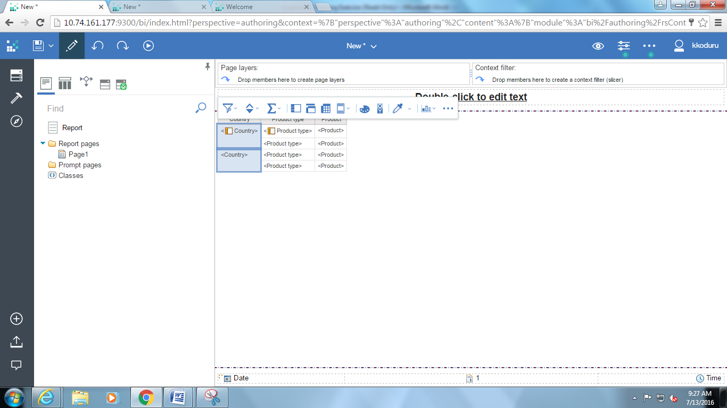

Run the report again to see the effect of grouping the columns. Your results will appear in a separate Cognos Viewer window like the one below. Note that the window below shows a partial list; scroll down to see the remaining data.  
  
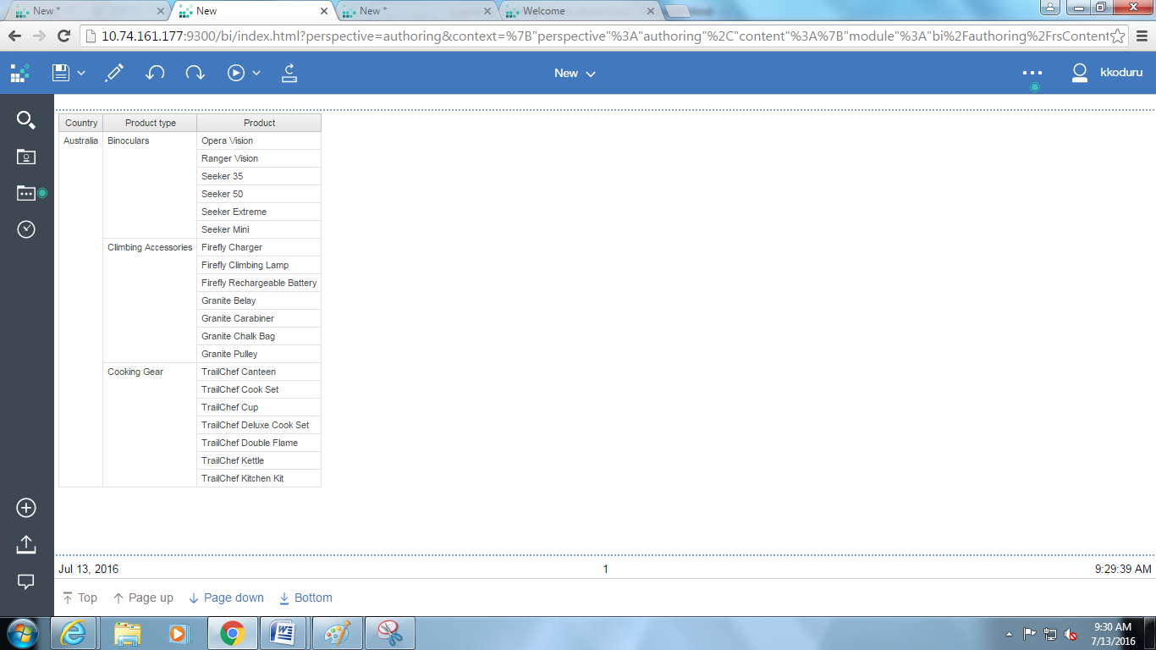

### Create a New Cross-tab Report

1. On the Cognos connection, click the New  button to create a new report.
2. In the New box, select Crosstab 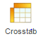 and click OK. You will see a window work area like the one below:  
     
   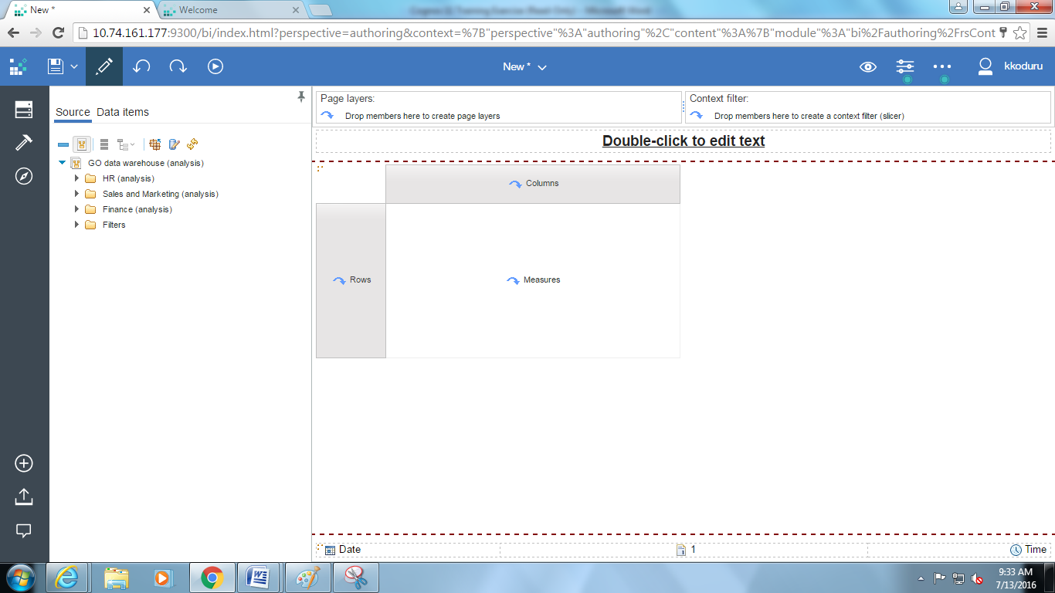
3. On the Source tab, expand the **Sales and Marketing** item and then **Sales** item by clicking on the plus sign.
4. Expand **Product** item and click **Product type** to select it and drag the selection to the Columns section of the work area. When you see the bold black bar above Columns, release the mouse button.
5. Expand the **Retailer** item by clicking on the plus sign. Click **Retailer type** to select it and drag the selection to the Rows section of the work area. When you see the bold black bar to the left of Rows, release the mouse button.
6. Expand the **Sales Fact** item by clicking on the plus sign. Click Quantity to select it and drag the selection to the Measures section of the work area. When you see the Measures area flash black, release the mouse button.
7. Run the report. You will see a window like the one below. The intersection of the rows and columns shows the number of product types sold by each retailer type.

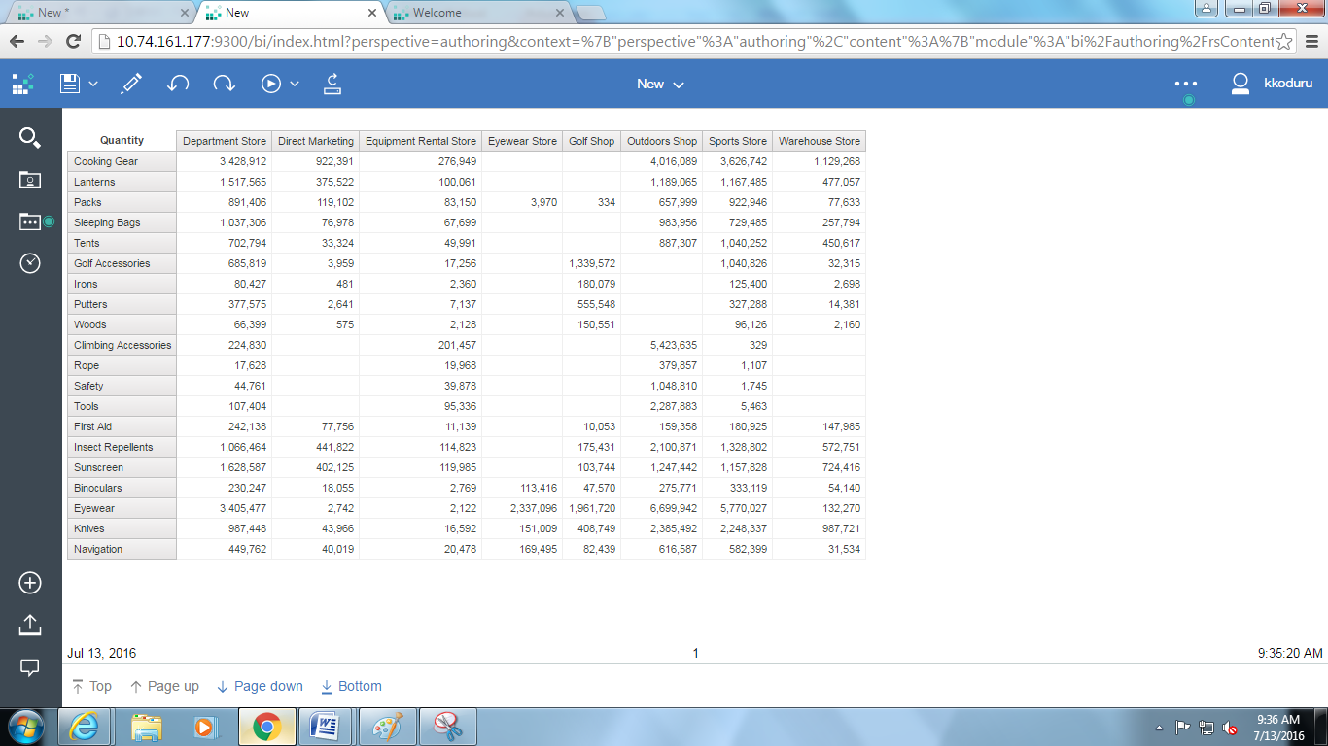

1. Suppose you want your crosstab report to show how many of each individual product was sold by each retailer type. You can nest information by dragging additional items into the report rows or columns.
2. In the Product item, click Product to select it and drag the selection to the right of Product type in the Rows section of the work area. When you see the bold black bar, release the mouse button.
3. Run the report and compare the results with those in step 7 above.  
     
   Next you will add an additional measure to the cross tab. When you do this, each measure is shown as a column.
4. In the **Sales fact** item, click **Revenue** to select it and drag the selection to the right of one of the Quantity items in the Measures section of the work area. When you see the bold black bar, release the mouse button.
5. Run the report. Your Cognos Viewer window should now look like the one below. Scroll down to see the rest of the information.  
     
   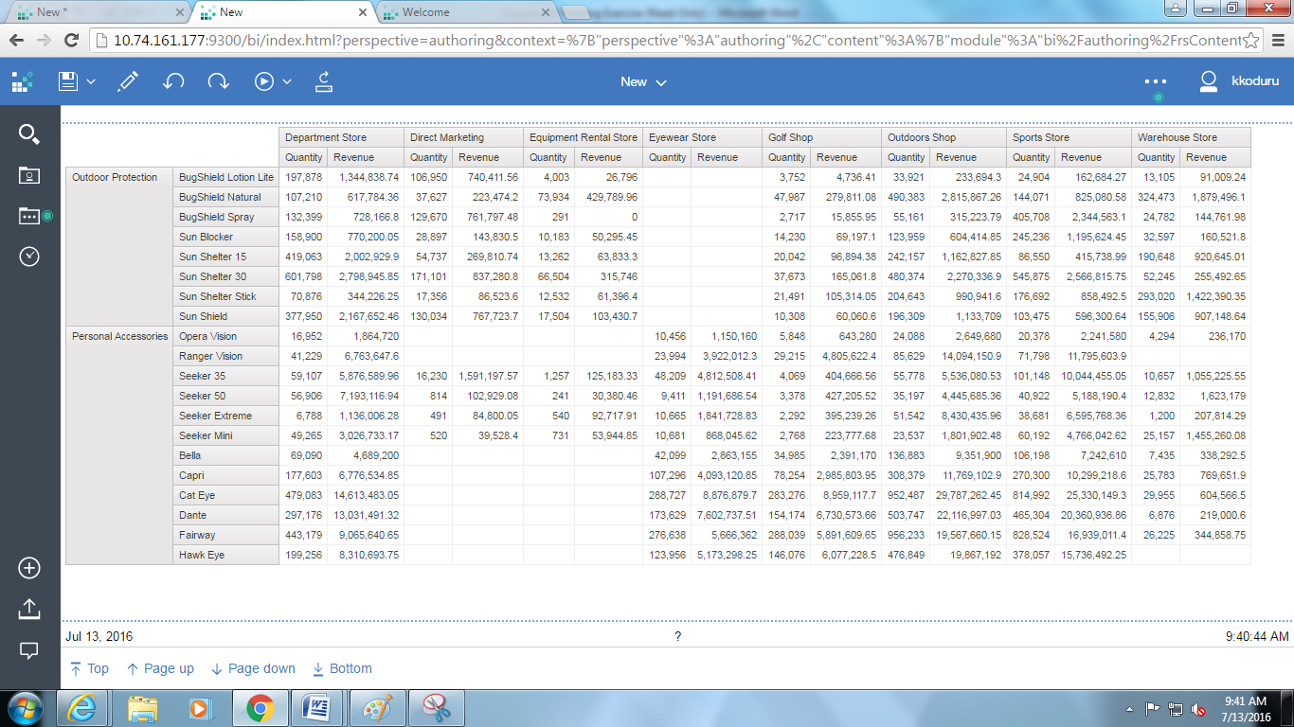  
     
   At times, a crosstab report may be easier to read if you swap the rows and columns. To do this:
6. In the Report Studio window, click the Sales territory column title. On the toolbar, click the Swap Rows and Columns  button.
7. Run the report and compare the look of the report with that in step 12 above. Close the Report Viewer window
8. On the Report Studio window File menu, click Save As.
9. In the Save As Name box, type report name Nested Crosstab. Click Save.

### Create a Column Chart

1. On the Cognos connection, click the New  button to create a new report
2. In the New box, select Chart and click OK

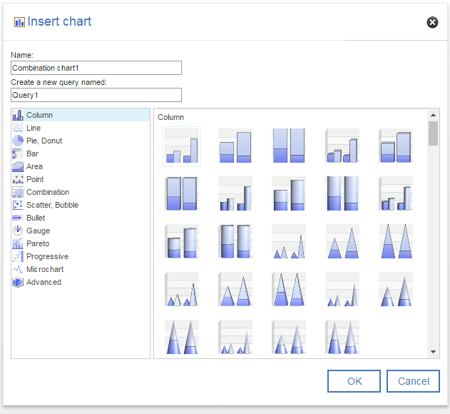

1. Click the icon for the Column chart and click OK. You will see a work area pane like the one below:  
      
   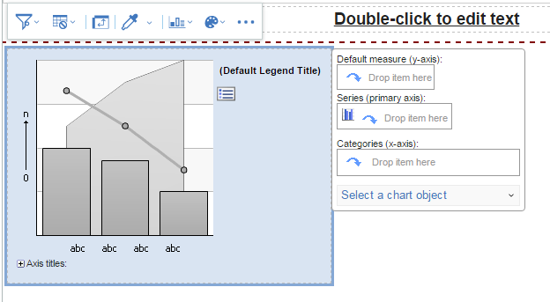  
     
   Note the three drop zones. Also note the corresponding numbers on the chart itself that indicate where the data will appear.
2. On the Model tab, expand the **Sales Fact** item. Click **Quantity** to select it and drag the selection to the Measures drop zone of the chart.
3. Expand **Time dimension** item and click **Year** to select it and drag the selection to the Categories drop zone of the chart.
4. Expand **Order method** and click **Order method dimension** to select it and drag the selection to the Series drop zone of the chart.
5. Run the report to see the chart you have created. The chart itself will look like the one below:  
     
   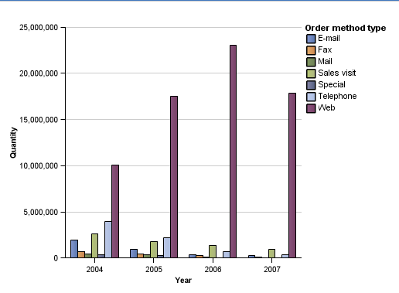
6. In the Report Analytics, click the Measures drop zone (it now reads Quantity). Note the properties you can apply to the Quantity item.
7. In the Properties pane, change the Custom Label property under **Chart Labels** heading to **Show**. Another line of text appears below ‘Quantity’ in Measures drop zone. Click there to change its properties. Select Text property and click the box with the ellipses at the end of the Text row. (Ellipses indicate that there are additional options for the property).
8. In the Text box; type **Number of products sold** and click OK. Run the report again to see the title change on the Y axis.
9. On the File menu, click Save As.
10. In the Save As Name box, type report name Sales Chart. Click Save.

### Visualizations

1. On the Cognos connection, click the New  button to create a new report
2. In the New box, select Blank and click OK
3. From Tool bar drag the Visualization in to report page

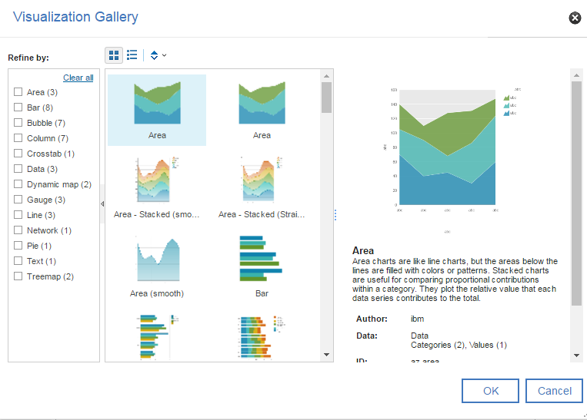

Select combination chart

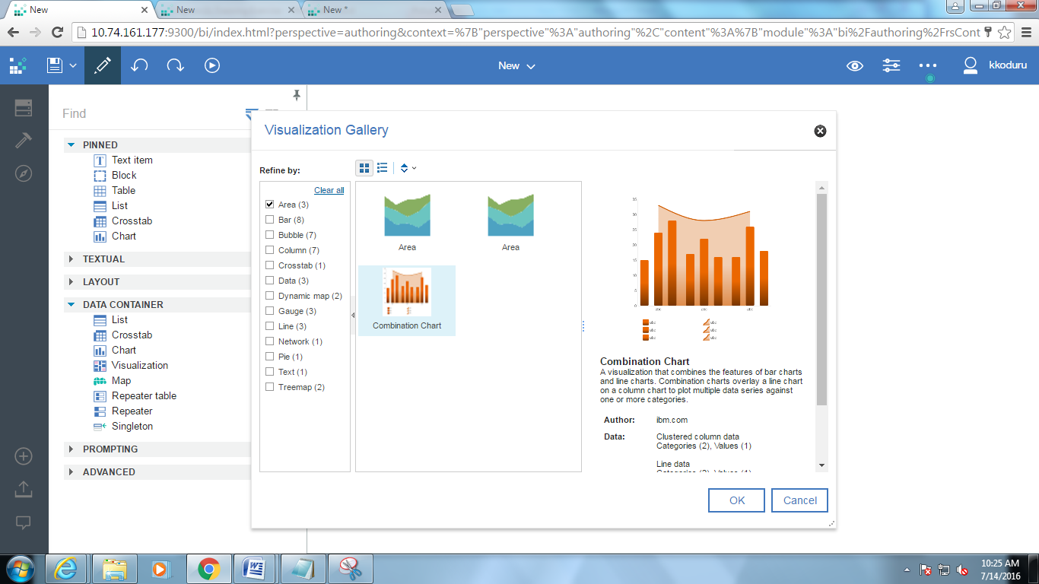  
  
On the Source tab, expand the **Sales and Marketing** and drag the below fields as shown below

* Order Method
* Product Line
* Organization
* Revenue
* Gross profit

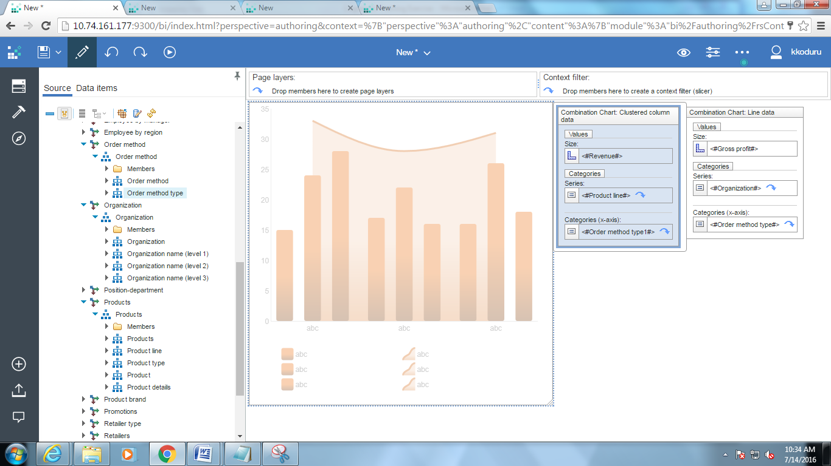

Run the report

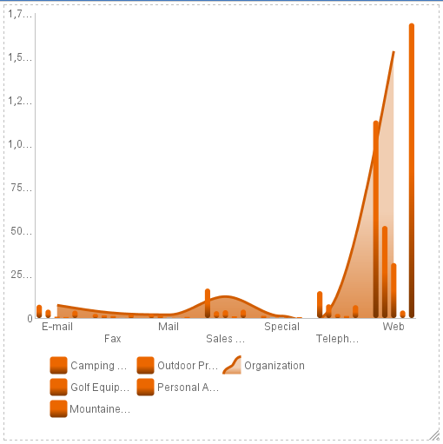

1. On the File menu, click Save As.
2. In the Save As Name box, type report name ‘Sales Visualization’ Click Save.

### Add a Prompt

1. On the Cognos connection, click the New  button to create a new report.
2. In the New box, select List and click OK.
3. On the Source tab, expand the **Sales and Marketing** and then **Product Forecast** Item.
4. Expand **Product** item, drag **Product type** and **Product** into the work area.
5. Further expand the Product item, double click **Introduction date** to insert the item in work area.
6. Finally expand **Sales fact** item and drag **Revenue** to the right of the items in the work area (release the mouse button when you see the bold black bar).
7. Click the title of the Product type column then, on the toolbar, click the Group/Ungroup  button to remove duplicate values.
8. Click the title of the Introduction date column then, on the toolbar, click the Sort button’s down-arrow and select Sort Ascending.   
     
   Note: Steps 5 and 6 simply provide some order (removing duplicate values and sorting) to your report before you work with it further.
9. Run the report to see the available data:  
     
   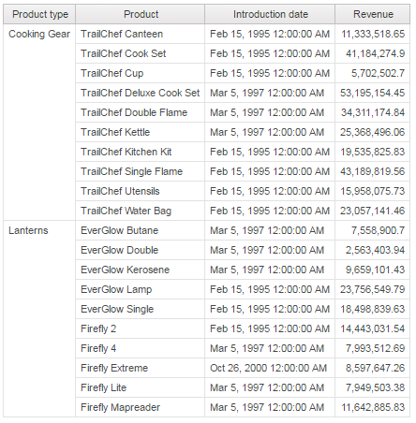  
     
   Page down to see the rest of the data. Note that the return dates are in ascending order.
10. Click the Filters button on the Report toolbar. In the Filters window, click the Add button and create the following filter (this filter contains a parameter named PDate):  
      
    [Introduction date]>?PDate?
11. Click the Validate  button then click OK. Click OK a second time to return to the Report window.
12. Run the report. You will notice that the Report Viewer window requires you to choose a date and a time to see the data in your report:  
      
    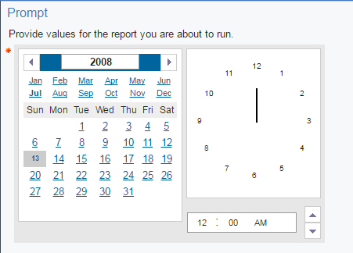
13. Click the left arrow beside the year (2008) bar until the year reads 2006. Change the calendar to July 11 by clicking the month and day. Leave the time as is and click OK (you may have to scroll down to see the OK button). Now your report looks like the one below with only information for returns after July 11, 2006 included. Page down to see the rest of the data.  
      
    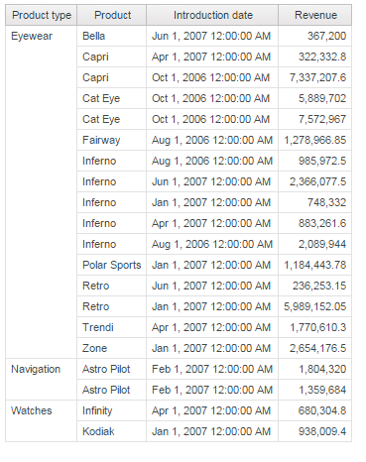
14. If you want to remove the filter you’ve created in this report, click the Filters button on the Report window toolbar, highlight the filter then click to remove it. Click OK.

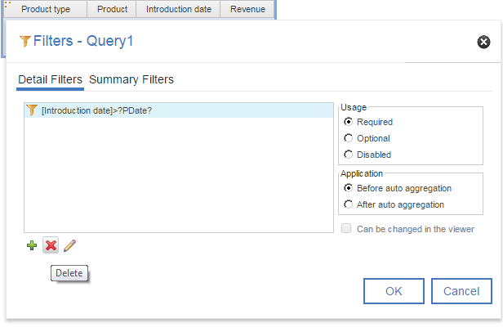

1. If you want you can create custom prompt page and from toolbar we can add desired prompts.

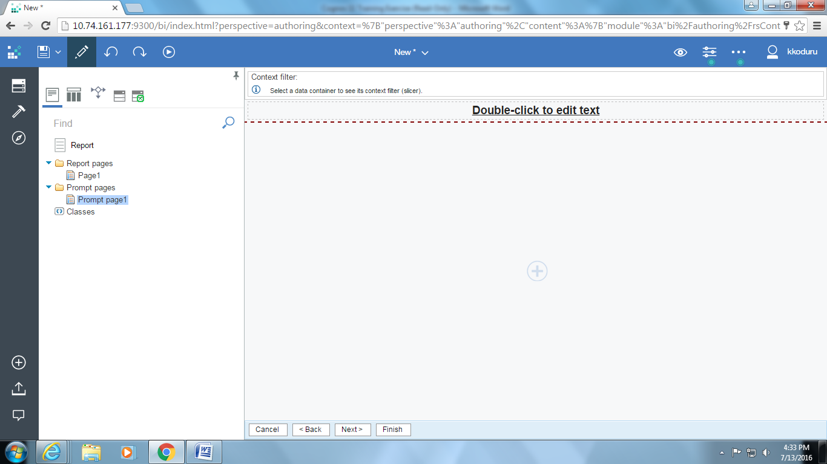

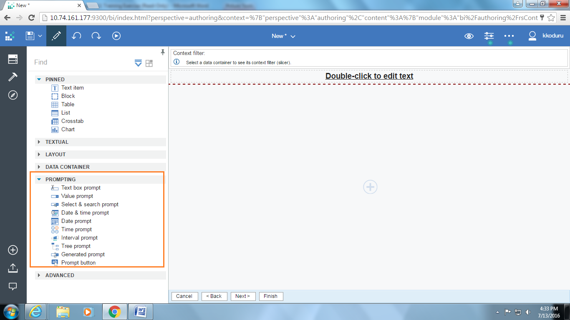

### Build a Cascading Prompt

1. On the Cognos connection, click the New  button to create a new report. If you are asked if you want to save the previous report, click Yes.
2. In the New box, select List and click OK.
3. On the Source tab, expand **Sales and Marketing, Sales** and then **Product** item; Click **Product type**. Hold down the CTRL key and click **Product**. Expand **Product**, continue to hold down the CTRL key and click **Product description**.
4. Continue to hold down the CTRL key, expand the **Sales fact** item and click **Unit cost**. Drag your selections to the work area.
5. Click the title of the Product type column then, on the toolbar, click the Group/Ungroup  button to remove duplicate values.
6. Click the title of the Product type column then hold down the SHIFT key and click the title of the Product column.
7. On the toolbar, click the Build Prompt Page . Based on the report items you selected, Report Studio will build a prompt page that looks like the one below:  
     
   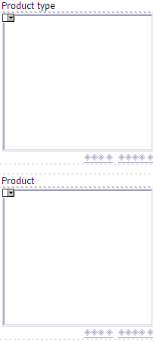  
     
   This time, the prompt page contains two text boxes, based on the types of items you selected. You will next create the cascading prompt.
8. Starting at the bottom of the prompt page, click inside the Product prompt box.
9. In the Properties pane, under General, click Cascade Source.
10. Click the Ellipsis button and, in the Cascade Source box that appears, use the pull-down arrow to select Product type. Click OK.
11. Next, click inside the Product type prompt box.
12. In the Properties pane, under General, click Multi-Select then, using the pull-down arrow, select No.
13. Again, under General, click Auto-Submit then, using the pull-down arrow, select Yes.
14. Run the report. In the Report Viewer window, you will only see values in the Product type prompt box. When you click a product type, names of specific product types appear in the Product box.
15. In the Product type prompt box, click Binoculars.
16. When the values for Binoculars appear in the Product prompt box, click Seeker 35 78110. Your report will look like the one below:



1. Close the Report Viewer window.
2. Save the report.

### Perform a Calculation on a Report

1. On the Cognos connection, click the New  button to create a new report
2. Make sure that Package is **Go Data Warehouse (analysis).**
3. In the New box, select **List** and click **OK.**
4. On the Source tab, expand the Sales and Marketing item and then Sales item.
5. Expand **Product** item by clicking the plus sign and Click **Product type.**
6. Hold down the CTRL key, expand the **Order method** item, click **Order Method dimension.**
7. Expand **Sales Fact** and click **Quantity** and **Unit Cost.**
8. Drag the selected items to the work area and release the mouse button when you see the bold black bar
9. You will see a window like the one below:

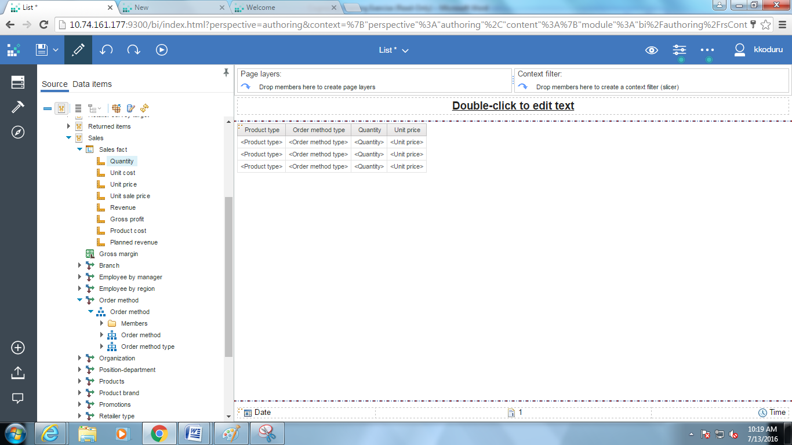

1. In the Report window click the title of the Product type column to select the column and click the Group/Ungroup  button on toolbar.
2. Grouping adds a symbol to the selected column to indicate that column is grouped. Your report columns now look like the ones below:

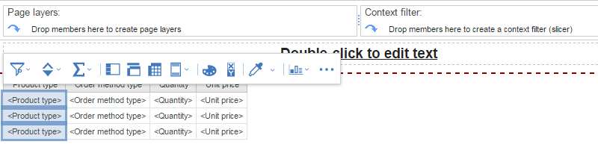

1. To create calculation, on the **toolbox** , Click on **Query Calculation** and drag it into the list.

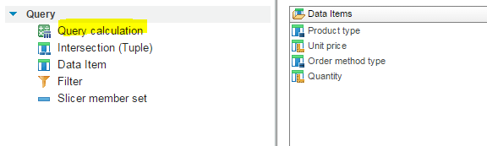

1. Enter the calculation name as **Revenue** in the **Calculation** dialog box and click **OK**.

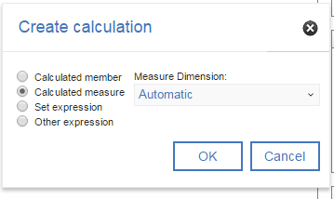

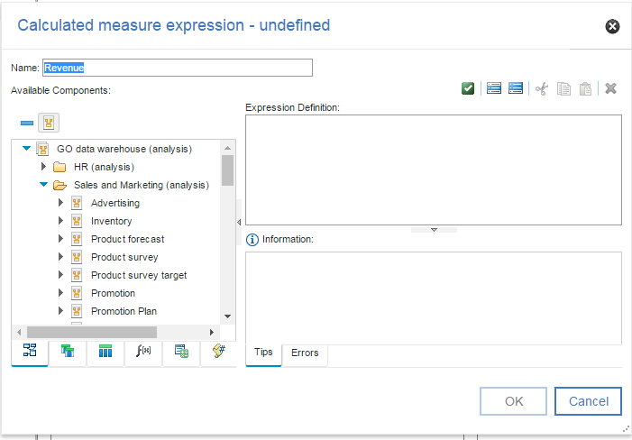

1. In the Data Item expression window, on source tab expand **Sales Fact** and double click on **Quantity** item.
2. On function f(x)  tab, expand operators and double click on “**\***”. Switch back to source tab and drag and drop the **Unit Cost** item into expression definition. Click **OK**

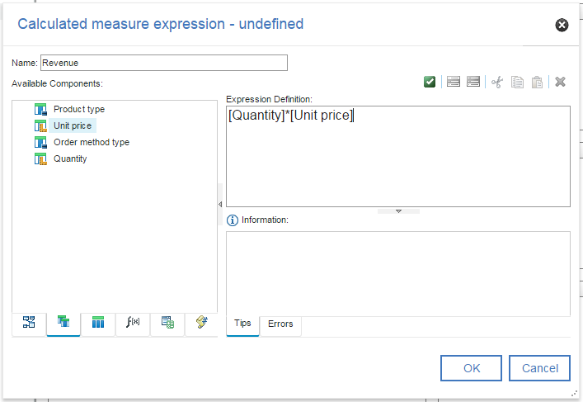

1. The **Revenue** column needs to be formatted to be more understandable.
2. Click heading of the **Revenue** column; from the properties window, select **Data Format** Property and click on “**…**” to set the properties. In the Data Format window set the **Format Type** as **Number** and set the **No. of Decimal Places** as **2** and **Thousands Separator** as **‘,’.** Click **OK**

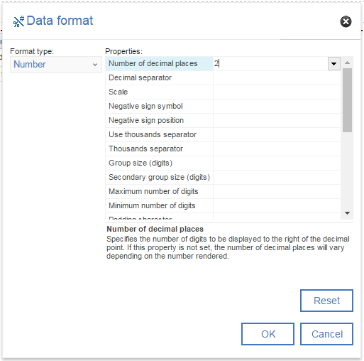

1. Run the report and it should look like the one below.

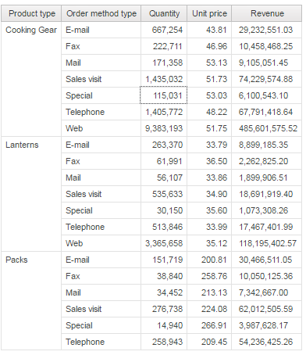

1. Save the report.

### Auto Group and Summarize Filter

1. On the Cognos connection, click the New  button to create a new report.
2. In the New box, select List and click OK.
3. On the Source tab, expand the Products item and click Product type.
4. Hold down the CTRL key, expand the Orders item, click Order date and then Quantity.
5. Drag your selections to the work area.
6. Click the title of the Product type item then click the Group/Ungroup  button on the toolbar.
7. Run the report to view the data then close the Report Viewer window.
8. Click the title of the Quantity item then click the Filters 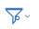 button on the toolbar.
9. To create a new filter. You will see a Tabular Model Filter window like the one below:

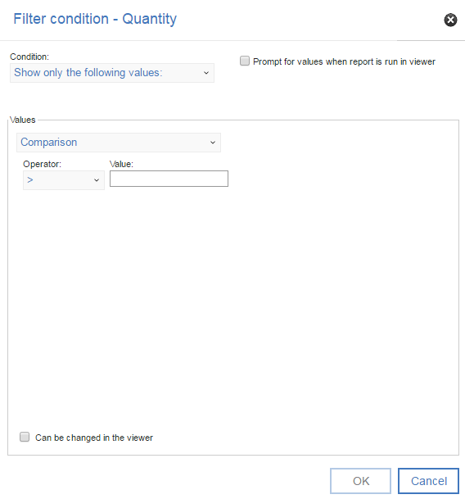

1. Click in the Expression Definition pane just after Quantity and type >=10000.   
   Click OK.
2. Run the report. You will see a Report Viewer window like the one below that now shows only quantities greater than or equal to 10000. Page down in the window to see all of the data.  
     
   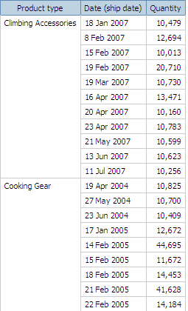
3. On the Report Studio File menu, click Save As.
4. In the Save As Name box, type report name Quantity Filtered. Click Save.

### Filter on Details

1. On the Report toolbar, click the New  button to create a new report.
2. In the New box, select List and click OK.
3. On the Source tab, expand the **Sales and Marketing** item and then **Sales** item.
4. Expand **Product** item by clicking the plus sign and Click **Product type.**
5. Hold down the CTRL key, expand the **Order method** item, click **Order Method dimension.**
6. Expand **Sales Fact** and click **Quantity**.
7. Click the title of the Product type item then click the Group/Ungroup  button on the toolbar to group Product type.
8. Run the report and notice the data in the aggregate report. A summary has been added for each Product type group.   
     
   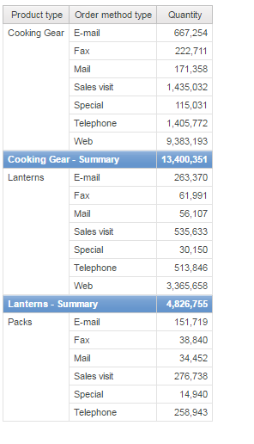
9. Click the title of the Quantity column and, on the toolbar, click the Filters  button.
10. In the Filters window, click  button
11. Click in the Expression Definition pane and type [Quantity]>7000.
12. Click the Validate  button to ensure that there are no mistakes in the expression. You will see the validation results in the Information pane of the Tabular Model Filter window. Then click OK. This returns you to the Filters window. Click OK.
13. Run the report. You will see a Report Viewer window like the one below that now shows only quantities greater than 7000. Page down in the window to see all of the data.  
      
    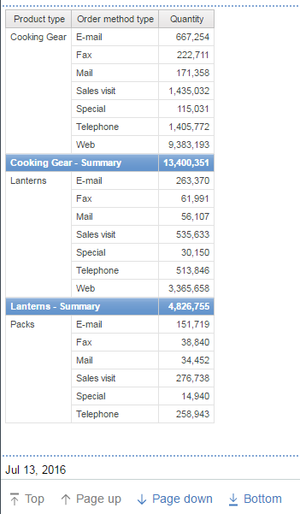

1. On the Report File menu, click Save As.
2. In the Save As Name box, type report name Filtered Details. Click Save.

In the following exercise, you will add a filter to the report you just created to produce a summary filter

### Create a Summary Filter

1. In the Filtered Details report, click the Filters button on the toolbar.
2. Click the filter you created earlier and then, in the Usage box, click Disabled.
3. Click the Add  button.
4. Click in the Expression Definition pane and type [Quantity]>5000.
5. In the Filters window Application box, click After aggregation and click OK.

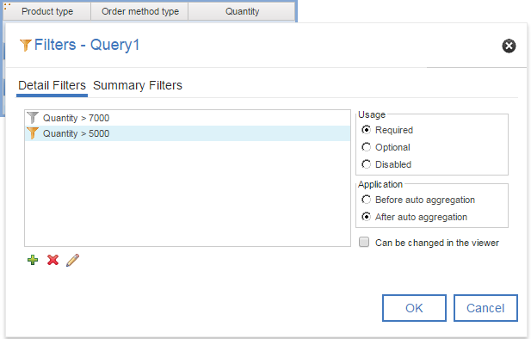

1. Run the report. The summary filter is being applied to the data after the aggregation:  
     
   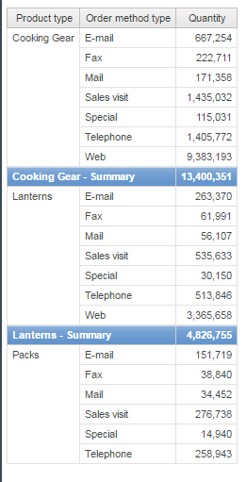

### Drill Through

1. On the Cognos connection, click the New  button to create a new report.
2. Make sure that Package is **Go Data Warehouse (analysis).**
3. In the New box, select **List** and click **OK.**
4. On the Source tab, expand the **Sales and Marketing** item and then **Sales** item.
5. Add the following data items to the list by double-clicking them:
   * + Order Method Dimension
     + Product line
     + Product type
     + Product name
     + Introduction date
     + Product Image

Tip: You can find these data items in Order Method and Product folders.

1. Group the Order method, Product line, and Product type columns.

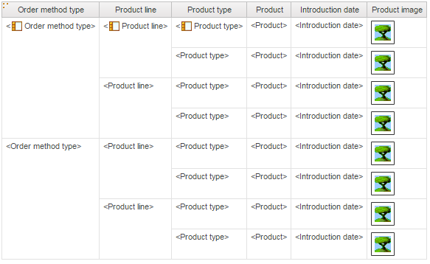

1. Click the filters button.
2. Click the add button, and type the following in the Expression Definition box:  
   [Product name]=?p\_PN?

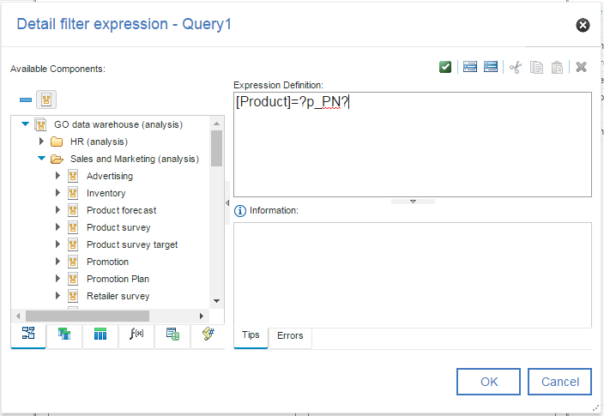

1. Click OK.
2. Repeat steps 8 to 9 to create the following filter:  
   [Order method dimension] in ?p\_OM?

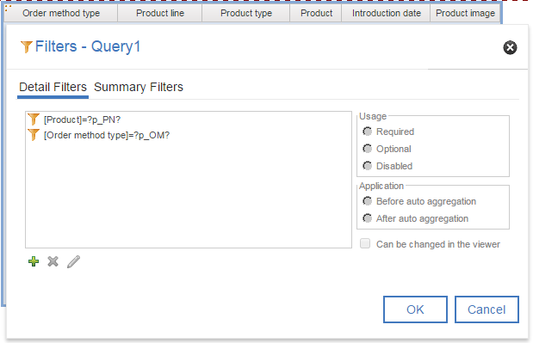

1. Change the title of the report to Product Details.
2. Save the report as **Drill through Target**.
3. From the File menu, click New to create a new report.
4. In the New dialog box, click List and click OK.
5. In the Insertable Objects pane, on the Source tab, add the following data items to the list:
   * Order method
   * Product line
   * Product type
   * Product name
   * Quantity
   * Revenue

Tip: You can find these data items in the Sales fact and Product folders.

1. Group the Order method dimension, Product line, and Product type columns.
2. Click the filters button.
3. Click the add button, and type the following in the Expression Definition box:  
   [Order method] in ?p\_OM?
4. Click OK.
5. Right-click the Product column and click Drill-Through Definitions.
6. Click the new drill through button .
7. Under Report, click the ellipsis (...) button and select the Drill Through Target report created previously.
8. Click Action and click Run the report.
9. Click Format and click HTML.

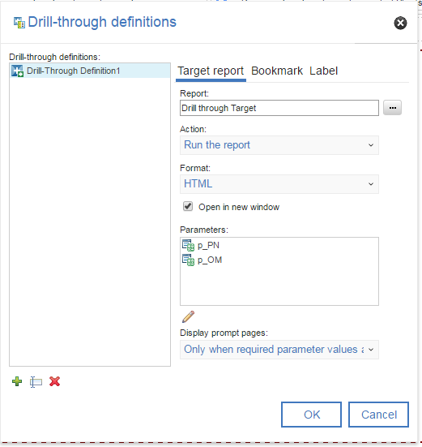

1. Click the edit button.
2. For the item p\_OM, under Method, select Pass parameter value, and select p\_OM for the Value.
3. For the item p\_PN, under Method, select Pass data item value, and select Product name for the Value.

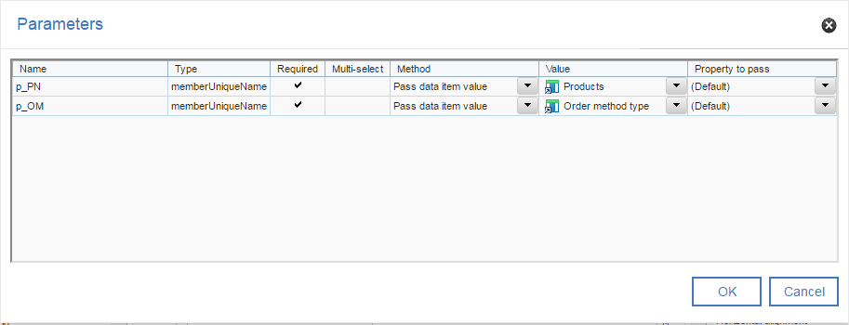

1. Click OK twice.
2. Change the title of the report to Product Revenue by Order Method.
3. Save the report as **Drill Through Source**.
4. Click the run report button.

When the report runs, you are prompted to select one or more order methods. When you click OK, the list shows the product names as clickable links. When you click a product name, the second report runs, showing the order method that was selected in the prompt page of the source report and the product (the source report’s column value) selected in the first report.

### Master Detail Report

1. On the Cognos connection, click the New  button to create a new report.
2. Make sure that Package is **Go Data Warehouse (analysis).**
3. In the New box, select **List** and click **OK.**
4. On the Source tab, expand the **Sales and Marketing** item and then **Sales** item.
5. Drag the following Items into the work area.

* Employee
* Sales Order
* Order number

1. On the Report toolbar, click the Unlock button.
2. On the Toolbox tab, click List. Drag it to the Order number column and drop it just after the first Order number data item (<Order number>) when you see the small Blinking black line.

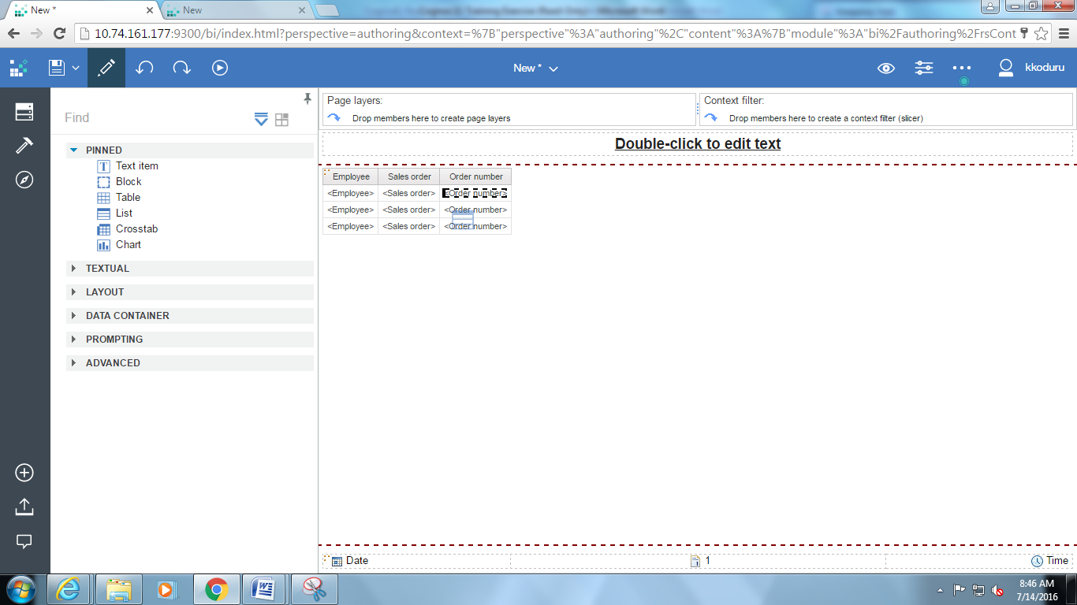

**Note: Drag the order number up so that is appears as in the report shown below.**

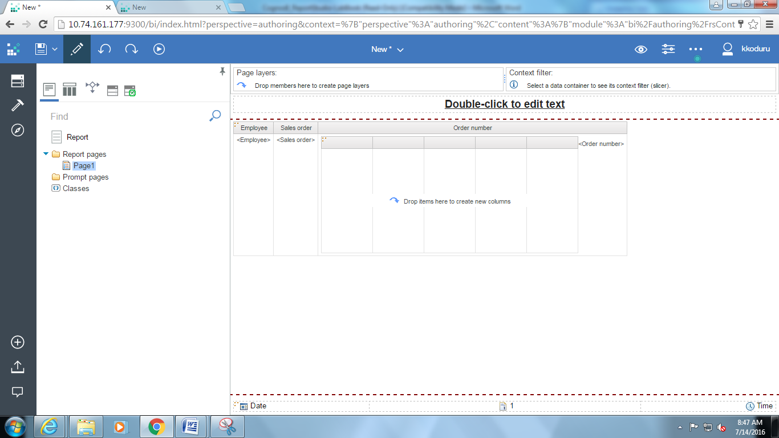

1. Unlock the second list report and drag the following items in the second list frame.

* Order Number
* Products Line
* Quantity

Revenue

Select the order number in the second list and Select Master/Detail Relationships in Properties Pane

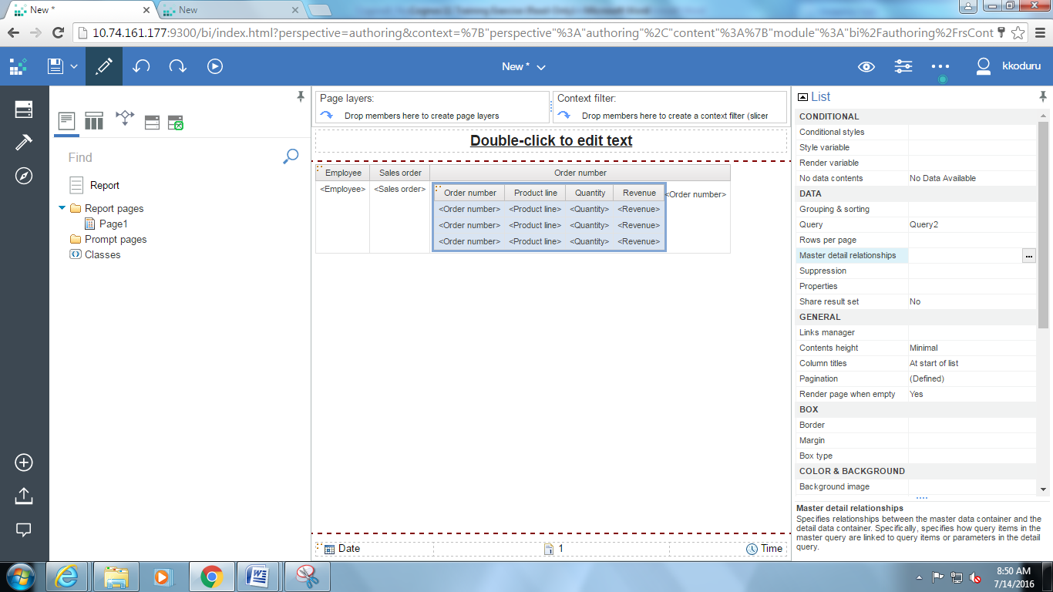

Select New Link, and then click Order Number in Query 1 and Query 2, and Link them.

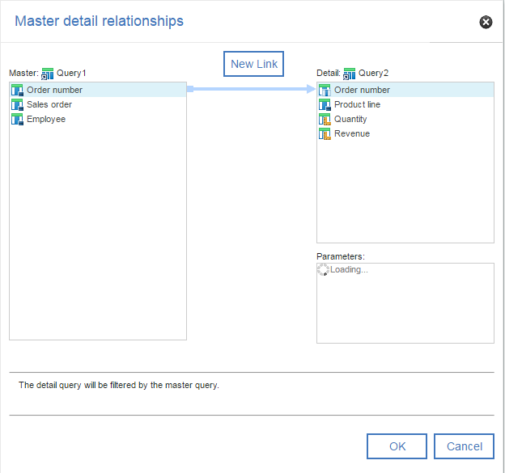

Run the report. View the report.

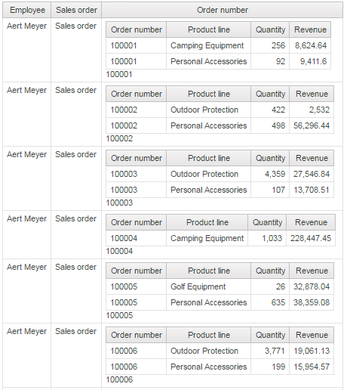

Save the report.

### Conditional Formatting

1. On the Cognos connection, click the New  button to create a new report.
2. Make sure that Package is **Go Data Warehouse (analysis).**
3. In the New box, select **List** and click **OK.**
4. On the Source tab, expand the **Sales and Marketing** item and then **Sales** item.
5. Add the following data items to the list by double-clicking them:
   * + Year
     + Product line
     + Gross Profit
6. To open the Condition Explorer pane and click Variables. Double click Boolean Variable button and name it as Low \_Profit

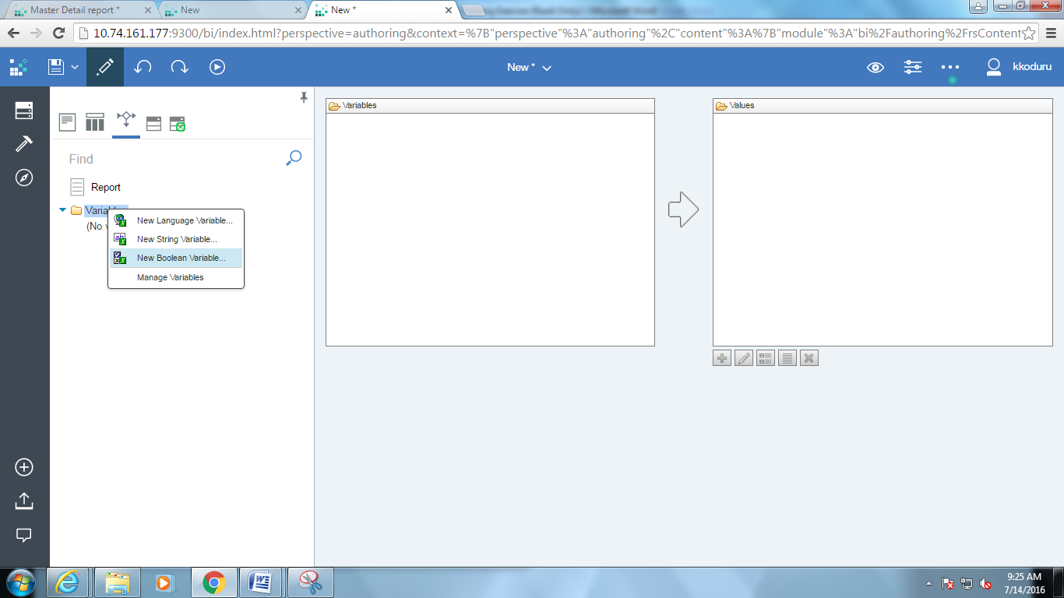

1. In Report Expression window, type the Expression Definition as GROSS\_PROFIT<3000000. Click OK.

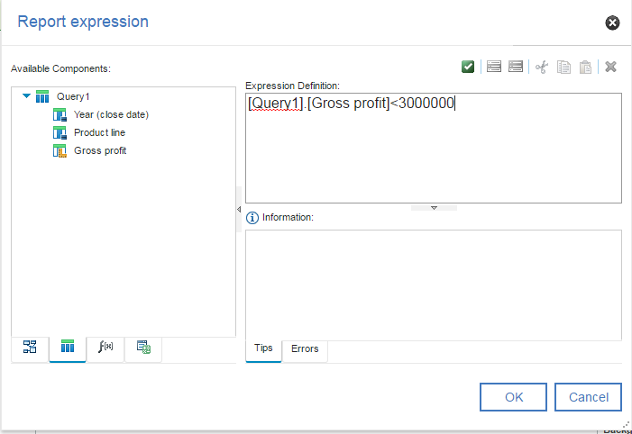

1. Go to the Page Explorer view. Select the Gross profit column. Click the Style Variable property, and select the Style Variable as Low\_Profit.

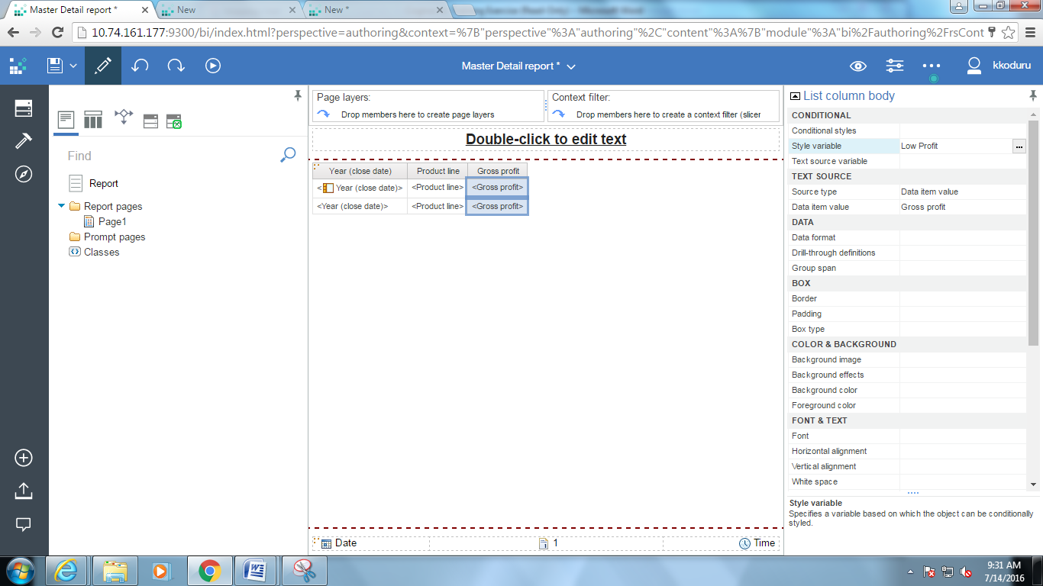

1. Go to Condition Explorer view. Click the data value Gross Profit. Select the variable value as Yes. In Properties pane, double click Background Color property under Color & Background section.

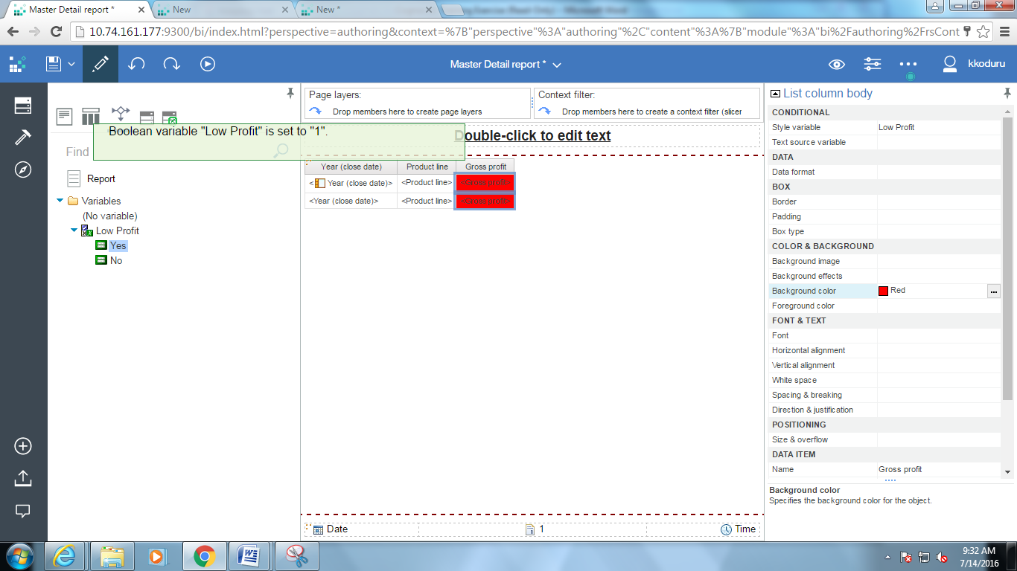

1. In the Background Color dialog box, select Red under Named Colors tab. Click OK.

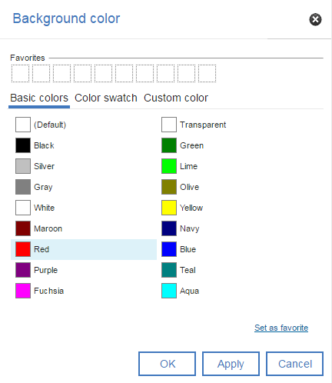

**Note**: If the report is run now, the background color will be red where the Gross Profit is less than 3,000,000.

1. Hold the cursor on the Condition explorer icon to open the Condition Explorer window. Select variable value as Low Profit 🡪 No. In Properties window, double click Background Color under Color & Background section, in the Background Color dialog box, select Lime under Named Colors tab. Click OK.

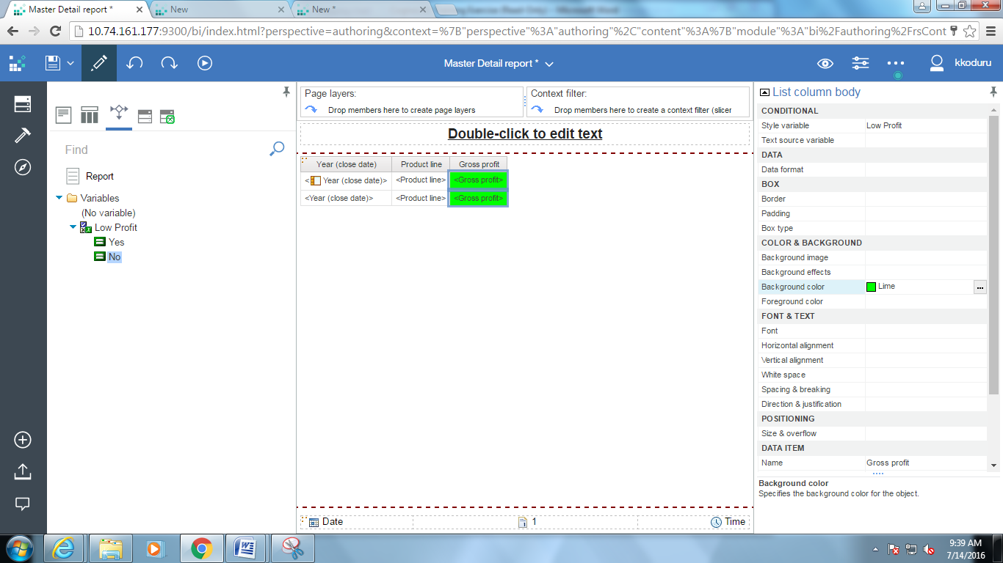

1. Run the Report. Close the report.

**Note:**

* The background color is Red where the Gross Profit is less than 3,000,000.
* The background color is Green where the Gross Profit is more than 3,000,000.

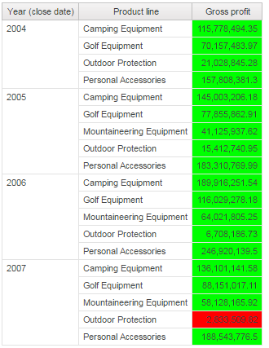

**Step 17:** Save the Report.

### Data sets

The feature's mission is to empower users to create and share business intelligence on their personal sources of data, without any assistance from IT. Users upload personal data files to create a Cognos package that can be used for report authoring and interactive analysis.

Click on External Data source symbol

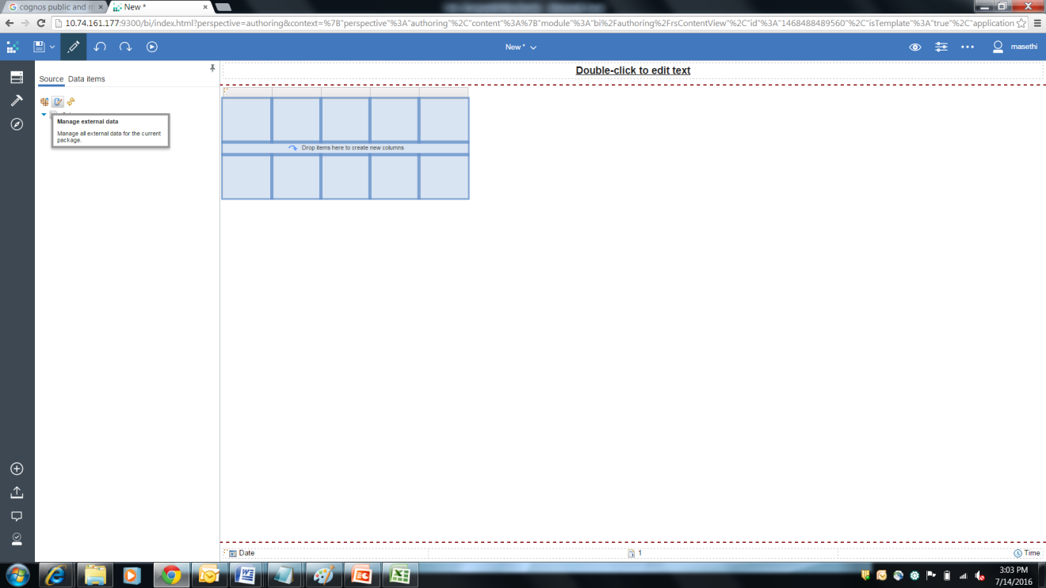

Choose File path

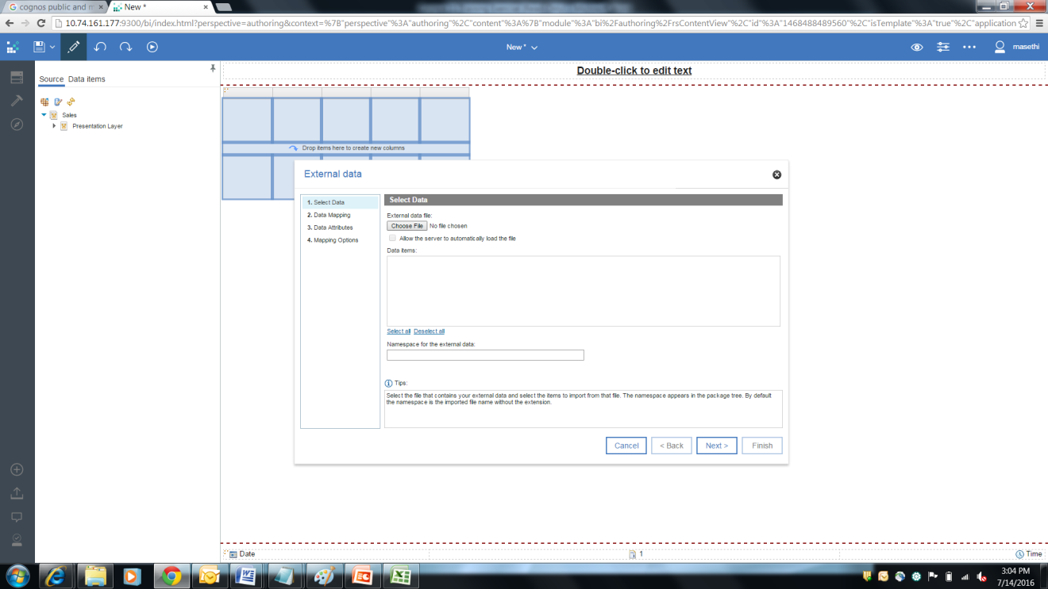

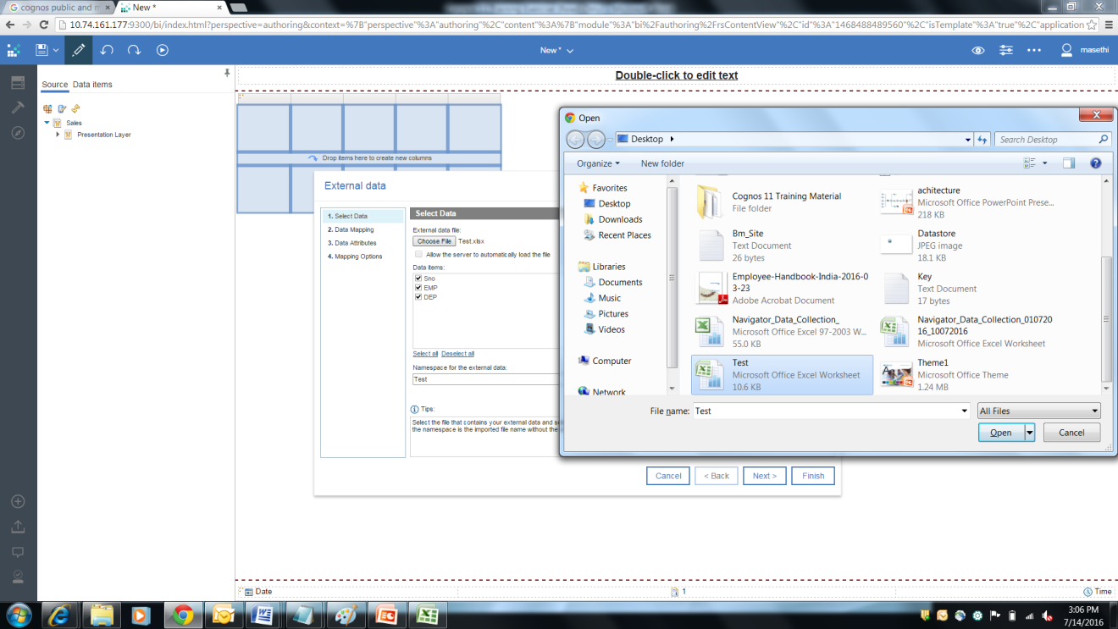

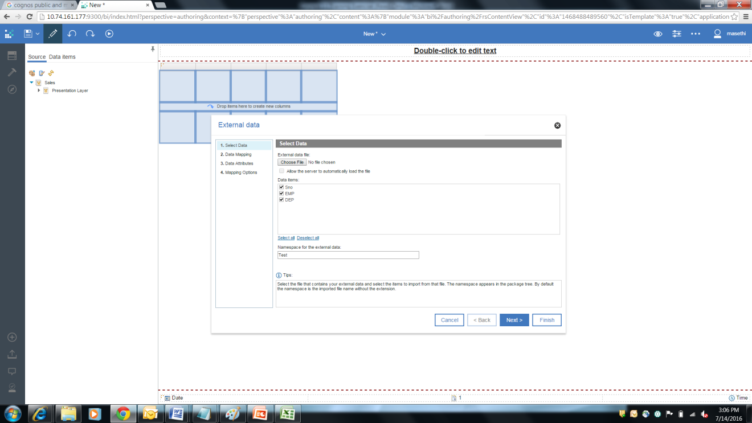

Click Finish and Publish the Package

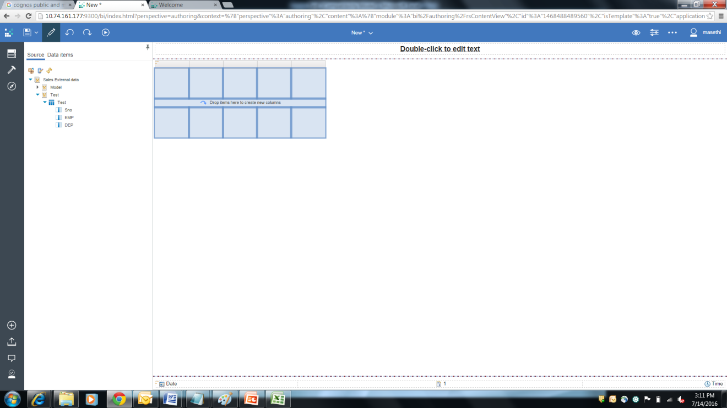

### Exercises

1. Generate a report for **Sales Performance** of a given region and quarter. Show Sales details by Product line and product type with details of Sales target, actual revenue and Variance from Target (Calculated field). The user is prompted to enter Quarter for which Sales performance has to be analyzed.

Region: Northern Europe (Filter)

Year = 2007 (Filter)

Quarter = Q1 (Prompt)

**Report output with above specifications**

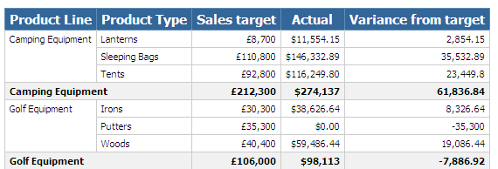

1. Generate a report to show **Sales by Product Line and Order method**. The report contains a crosstab and provides sales details (Quantity and Revenue) by product line, product type and Order method. Data in the report will be filtered to contain specific order methods. Also, show the Maximum values of the measures for each Product.

**Report Output** for Order method as E-mail, Sales visit, Telephone and Web.

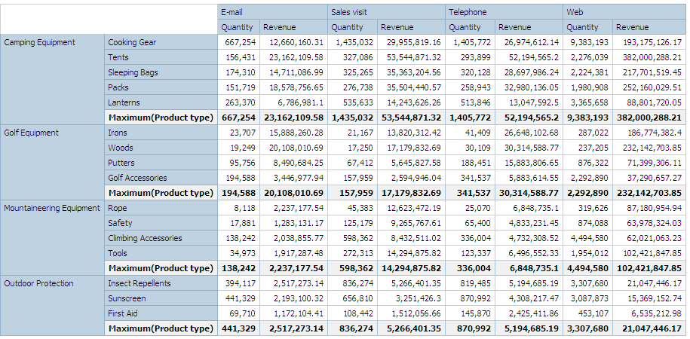

1. Generate a report for **Returns by Order method**. The report contains a crosstab and column chart and provides details of returned items by order method and return reason. The user is prompted to enter Order method before running the report.

**Report output** for Order method as 'Web'

